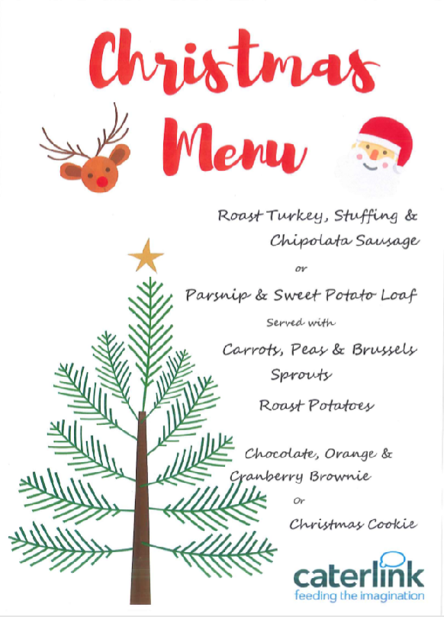

**Reply for Christmas Dinner – Wednesday 16th December 2020**

🗌 Yes my child would like a Christmas Dinner 🗌 NO my child would not like a Christmas Dinner.

Childs Name: _________________________________ Class: ______________________________

🗌 My child has a Universal Free School Meal 🗌 My child is in receipt of Free School Meals

🗌 I enclose £2.15 for a Christmas dinner 🗌 I have paid online for a Christmas dinner

Signed : ____________________________________________________________________

**Please return by Tuesday 2 December 2020.**

**Unfortunately, no orders can be taken after this date.**

**£2.15**

**Wednesday 16th December 2020**