Personal Social & Emotional Development  In PSHE, we will be exploring the topic ‘Being Me in My World’ and will be making a school anc class charter. We will also explore relationships. | Physical Development  - Healthy food.  - Getting myself dressed.  - Keeping safe.  - Pivots and pencil grips.  - Using space safely. |  | Communication & Language  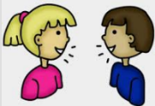  - Listening and responding to stories.  - Understanding questions.  - Asking questions about a story.  - Answering questions.
Maths  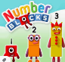  Reception:  - Numbers 1-5.  - Counting objects slowly & carefully.  - Recognising numbers.  - Representing amounts in different ways.  - Ordering numbers.  Y1:  - Numbers to 20 (and then 50).  - Making collections of 10s.  - Solving problems with numbers.  - Exploring coins.  - Using non-standard units of measure. | Ainslie Class Topic Web  Autumn 1 2020  Once upon a time in Nursery Rhyme Land…  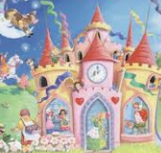 |  | Literacy/English  - Traditional tales and Nursery Rhymes.  - Rhyming words, playing with sounds.  - Finding out about different characters.  - Retelling stories and using puppets and pictures.  - Reciting and singing favourite and new rhymes.  - Stories with patterned and repetitive language.  Read Write Inc  - Reception Children will learn a new sound and grapheme each day. They will slowly begin to blend to read simple words and will learn how to form the letters.  - Y1 Children will be in their Read Write Inc Groups and will continue their learning each morning.
Understanding the World  Talking about the world around us, the people in our lives and the weather.  Beginning to use technology at home and at school.  Y1 Science Animals including Humans. Seasonal Changes Summer to Autumn. Y1 Geography Physical and human features of landscapes. Maps and symbols. Y1 Computing Logging on to a computer. Creating pictures on Microsoft paint and 2paint . |  | Expressive Arts and Design  - Singing, dancing, making music.  - Recreating pictures in stories.  - Creating our own pictures and collages.  - Using the Creative Area.  Y1 D.T. Moving pictures, with slides, levers and wheels. Cooking: Gingerbread men and sandwiches for our afternoon tea party. Y1 Music Prokofiev’s Peter and the Wolf. Composing our own music to tell a favourite story. |  | RE  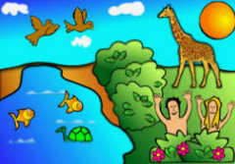  In RE we are exploring the Christian Creation story and why bread is used as a symbol in the lead up to Harvest.

