[](http://www.mountbatten.org.uk/)[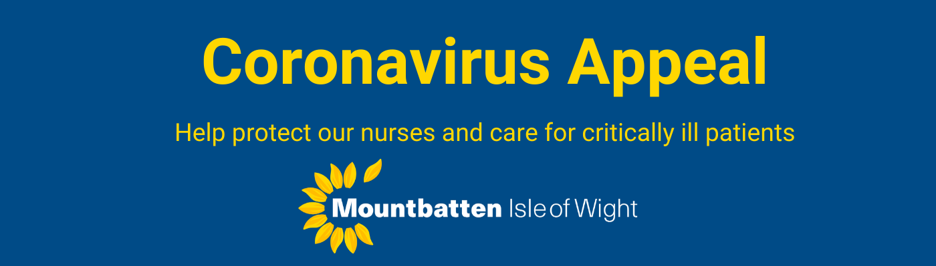](https://www.mountbatten.org.uk/donate/coronavirus-appeal/185/credit-card)

I hope you are all well & staying safe,  We are launching another virtual balloon race that coincides with when schools were meant to finish for the summer, setting off from Hogwarts School. It is a totally eco friendly balloon race, with the balloons being Virtual. The balloons can be given as gifts, and there is no limit on how many balloons one person wants to buy. The thickness of the balloon, amount of helium and the appearance of the balloon can all be changed! Once the race has started, it runs for 7 days and the balloons can be tracked on the website, so its a really fun way of seeing a bit of the world! There are also great prizes for the winning balloon!  We would be really grateful if you would share the link on your Schools facebook page? the balloons cost just £3.

<https://www.mountbatten.org.uk/Event/virtual-balloon-race-schools-out>

[Virtual Balloon Race | Mountbatten](https://www.mountbatten.org.uk/Event/virtual-balloon-race-schools-out)

Latest. Virtual Balloon Race. Join the Schools Out race from Hogwarts School of Magic! You don't have to be in school to join in...any age welcome.

[www.mountbatten.org.uk](http://www.mountbatten.org.uk)