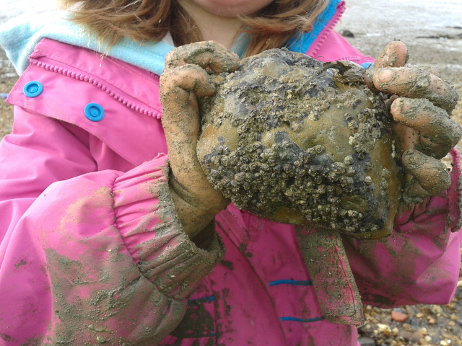 

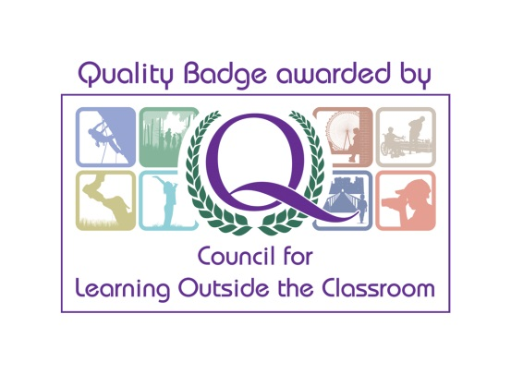­­­

Funded by “Down to the Coast”

**Please book your place with us:**

Kelly Wetherick

Wildbeach Officer

[kelly.wetherwick@hiwwt.org.uk](mailto:kelly.wetherwick@hiwwt.org.uk)

07825 212473

£5 donation per session

At Wildbeach we use the Forest School ethos to enable children to explore, discover, create, play and learn, within a coastal environment.

Sessions take place at **Boulnor** on:

**Thursdays:**: **Nov 7th, 14th 28th & Dec 5th , 8th, 12th.**

**Wildbeach Tots** for under-fives with parents and carers

**10.00 am – 12.00 pm**

Sessions will begin at the Forest School site where we will then go on an adventure walk to the beach.

Wildbeach Tots