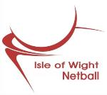 JUNIOR NETBALL

HALF TERM NETBALL ACTIVITY

COME & JOIN THE FUN
YEARS 3 - 6
PLAY NETBALL - GIVE IT A GO??
Fun, skills, shooting, match play
Club members welcome too.

Various venues around IW
Come to them all - different activities each day

WED 30 OCT COWES EC WINDER HALL

THURS 31 OCT RYDE ACADEMY SPORTS HALL

FRI 1 NOV SEACLOSE PARK OUTDOOR COURTS

All sessions 10am – 12 noon Cost £2

Wear suitable clothing, and trainers. At Seaclose – outside courts - please wear extra layers and have a coat. Bring plenty to drink – preferably water - and a snack.

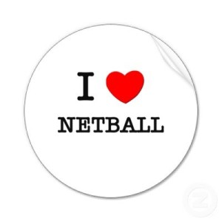
Sessions run by UKCC level 2 coaches

Please register your child by text to 07785750266 or by email - easelby47@gmail.com detailing name, age & all venues they are
attending.
On the day please ensure that your child is registered with organisers
We will need name, age, contact details in case of an emergency,
and any medical issues your child may have.

WE LOOK FORWARD TO WELCOMING MANY NEW YOUNG NETBALLERS – make use of half term to Come and Try It

