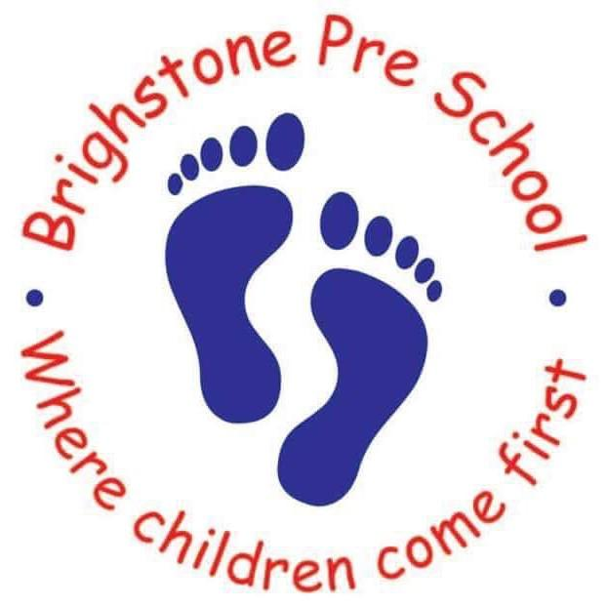
Easter Holiday Club 2019
Offering full day care for children 0-11

If you wish your child to attend the Holiday Club held at Brighstone Preschool, please fill in the form below with days and times required.

Our opening hours are 7.30am-5.00pm.

We charge £5 an hour for the first child and £4.50 for any subsequent children.

Please enter the hours you wish your child to attend on each given day.

Monday  8th April | Tuesday  9th April | Wednesday 10th April | Thursday  11th April | Friday  12th April | Number of hours
Monday  15th April | Tuesday  16th April | Wednesday 17th April | Thursday  18th April | Friday  19th April | Number of hours
Closed
Bank Holiday

Monday  22nd April | Tuesday 23rd April
Closed  Bank Holiday | Pre-school/  School open.

Childs name............................................................ DOB......................................

Childs name............................................................. DOB......................................

Contact No: …………………………………………………………….

Parent Signature: ................................................................... Date: …………………………………………

You will be required to complete a registration form with all your contact details and your child's details upon booking.

Many Thanks

Rosanna Riddett and Jayne Hill

