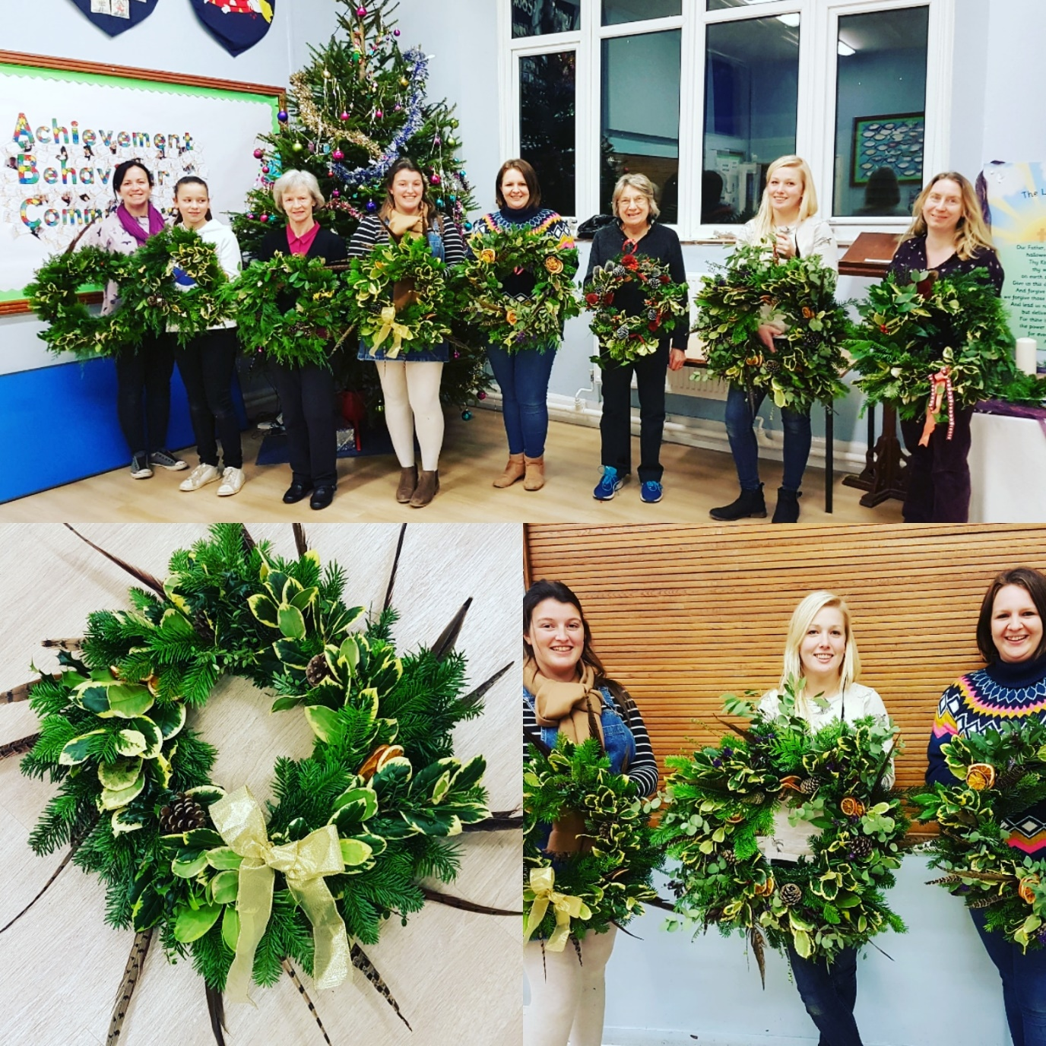
Wreath Making with Jackie Sothcott in the School Hall
8 ladies, £40 donated to the BSA.
Thank you Jackie!

