The Brighstone School Association are proud to announce:
Wreath Making Workshop
Wednesday 12th December
Brighstone School Hall
7pm – 9pm

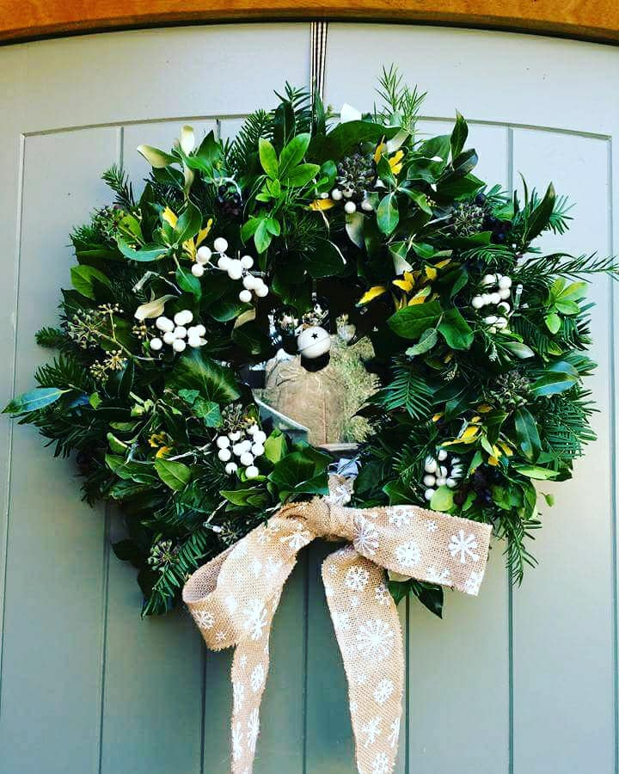

£12 per person
£5 from each ticket goes to the BSA
All Wreath rings & wire will be provided along with tea / coffee / mulled wine and festive treats.
Just bring a big bag of foliage, secateurs & any additional decorations you may wish to use.
Please text Jackie on 07795550424 with your name to book your space

Many thanks to Brighstone parent Jackie Sothcott for donating her time and energy to this fantastic event!

