MEET EAT
&

COMMUNITY MEAL, ALL ARE WELCOME

JOIN US ON THE
FIRST FRIDAY
of every month at NOON
Donations welcome
St Saviours Holy Family Centre
Weston Lane, Totland
Isle of Wight. PO39 0HE
Starting Friday 2nd November
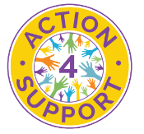

Call Sally on 07872 304 294 or email info@wwtb.org

