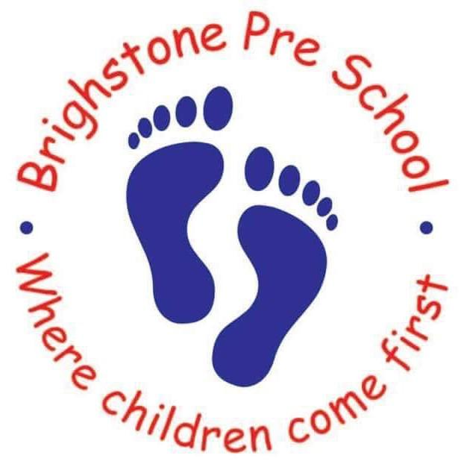
October Holiday Club 2018

If you wish your child to attend the Holiday Club held at
Brighstone Preschool, please fill in the form below with days and times required.
Our opening hours are 7.30am-5.00pm.
We charge £5 an hour for the first child and £4.50 for any subsequent children.

Week beginning  22nd October 2018 | Monday | Tuesday | Wednesday | Thursday | Friday | Number of hours
Name:

Name:

Childs name............................................................DOB......................................

Childs name.............................................................DOB......................................

Signed..............................................................................

You will be required to complete a registration form with all your contact details and your child's details upon booking.

Many Thanks

Rosanna Riddett and Jayne Hill

