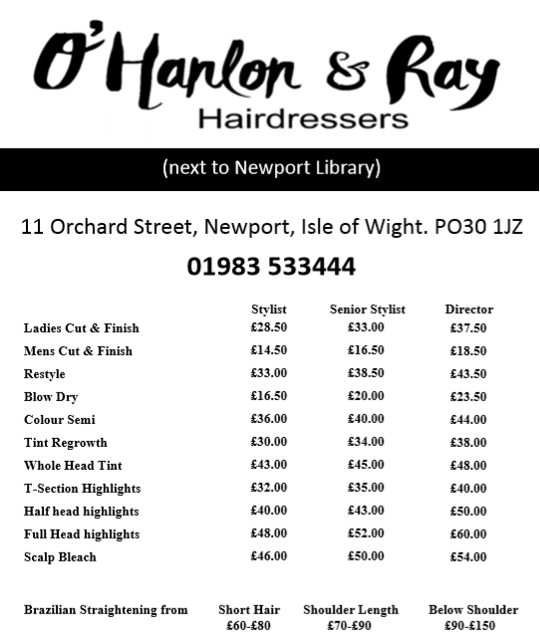
Introductory Offers…
with our talented senior stylist Emma!

Full Head Tint or Half Head Foils and
Cut & Finish…. £55

Brazilian Straightening….
20% Off - Prices from £70

Cut & Finish…. £25
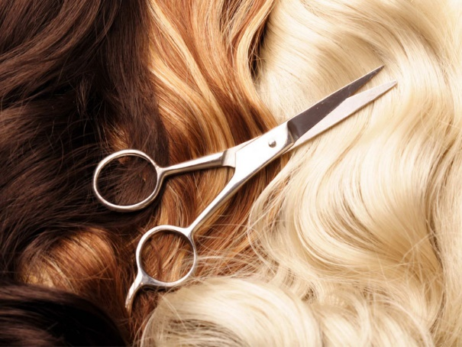
Restyle…... £30

Shellac Nails…. £15

