A group of people rowing a boat in the water

Description generated with very high confidence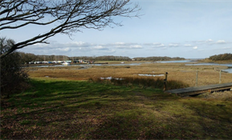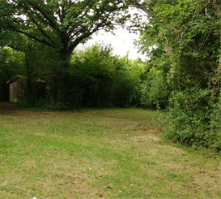

Pre-event registration: 5k or 2.5k adults and children £5 (£4 additional siblings) Pre-entry closes 1st May.

For more information search for the Facebook event or email corffunrun@gmail.com

CORF FUN RUN  
2.5k or 5k   
SATURDAY 5TH MAY  
Entry forms: corffunrun@gmail.com

All proceeds will go towards supporting international opportunities for Island Scouts

A family friendly 5k or 2.5k fun run at Corf Scout camp. The event is open to all ages whether you want to run, jog or even walk the distance. Medals for all finishers. Run starts at 2pm.