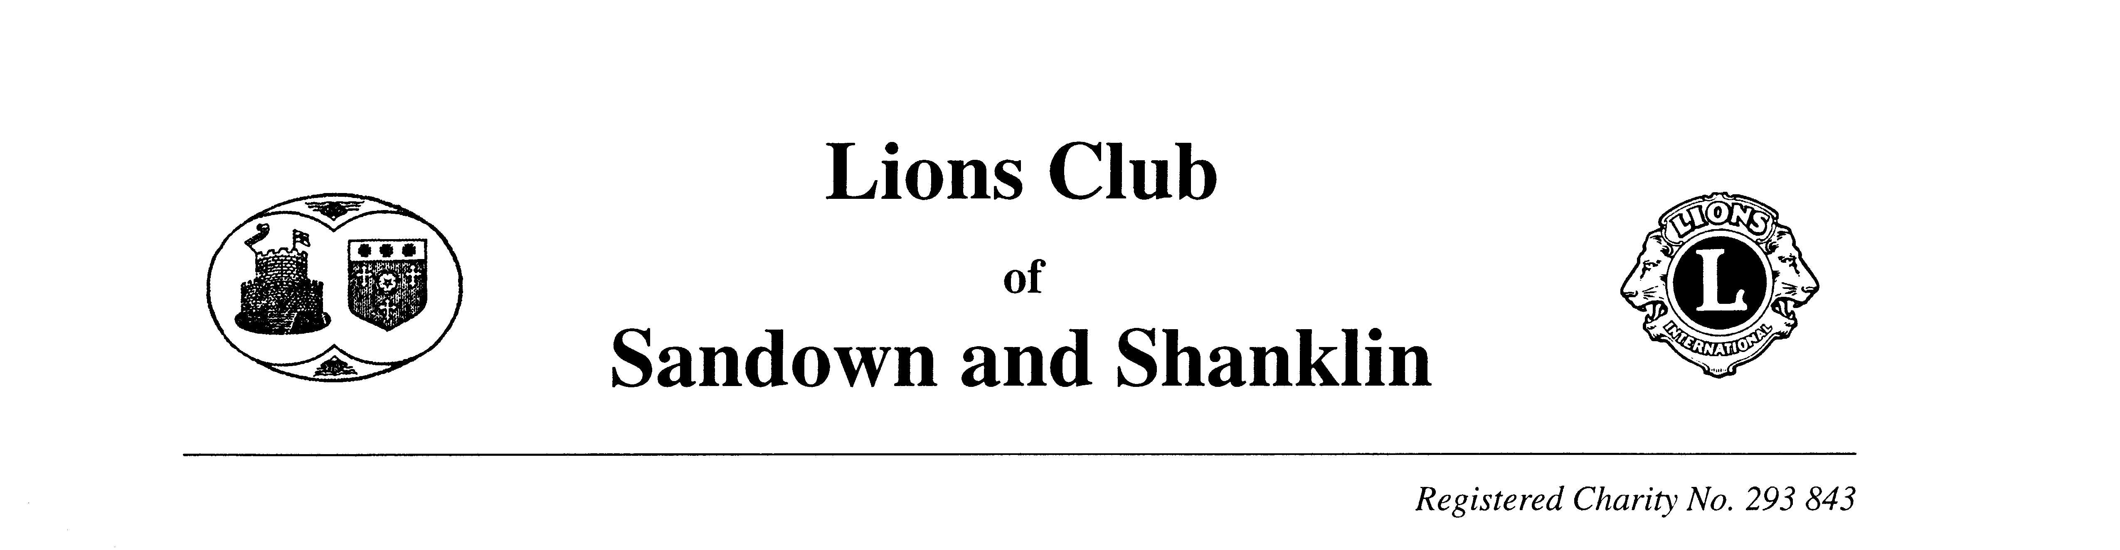


Mr. S. Raybould,
1, The Medeway,
Lake,
Sandown,
Isle of Wight,
PO36 9HG.

Tel: 07834680374

Swimarathon 2018

This year’s annual Swimarathon is being held on Saturday 28th April 2018, with the kind permission of the Management, at the Heights Leisure Centre, The Broadway, Sandown. Please support the Lions by entering one or more teams. There is no charge for entry.

This year the FUNDS RAISED by your team will be split 50-50 between a charity/local organisation of your choice and the specified Lions charities. We will collect the sponsorship in the normal way and present appropriate monies to the charities/local organisations specified by all the teams. This year the Lions are raising money to support the IOW MS Society, Sandown & Shanklin Independent Lifeboat and the Cinnamon Trust.

The teams will consist of six swimmers, swimming in relay for 55 minutes.

Awards will be presented to teams swimming the greatest number of laps in their category. General conditions are on the sponsor forms which will be sent on receipt of your application form. All swimmers will be presented with a Certificate.

Please support your Lions by filling in the enclosed application form now, remembering to specify your nominated charity/local organisation, join in the fun and help us to help others. Please feel free to copy the application form and pass it on to any one you may feel would like to participate in Swimarathon.

Yours sincerely,

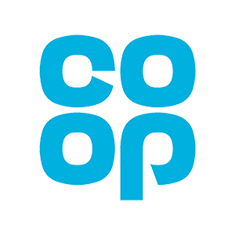
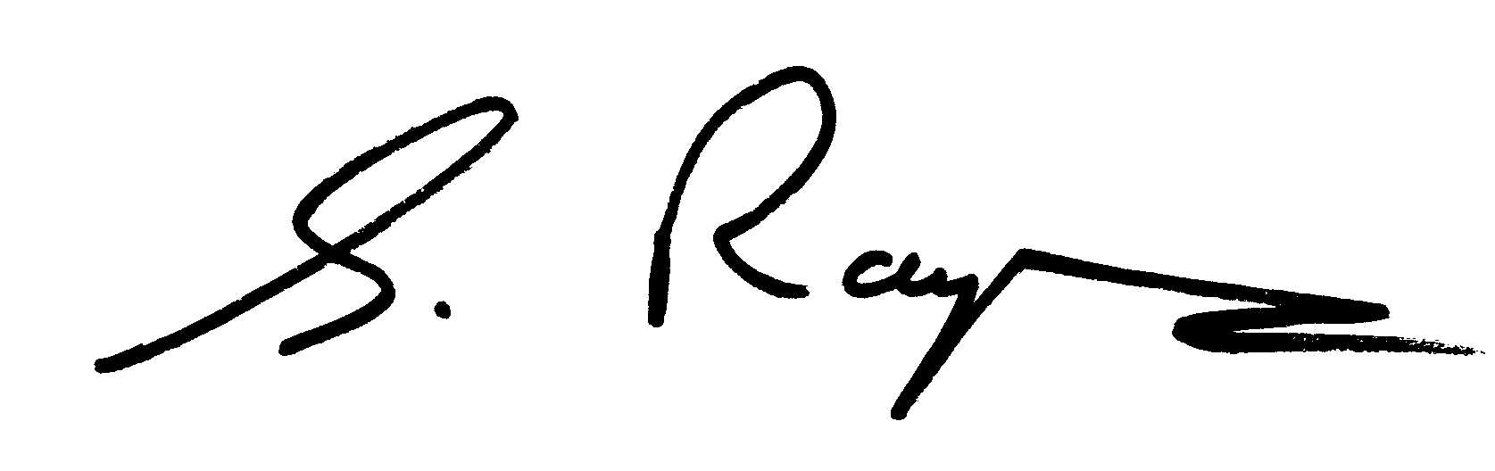
STEVE RAYBOULD - Swimarathon Organiser.

ENCL.

