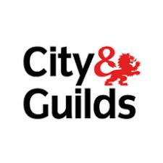
Develop your skills with Adult Community Learning.
City and Guilds: English and Maths Qualifications.
Qualifications up to GCSE ‘C’ or ‘4/5’ Equivalent Level
What’s in it for me?
Help your children with their homework and improve your skills
What are the course contents?
The contents are based on the National Core Curriculum.
English includes Reading, Writing and Speaking and Listening
Maths includes Number, Measure, Shape and Space, and Data Handling.
You learn what you need to, to fill the gaps in your knowledge.
How do I know what my gaps are?
We will carry out a diagnostic assessment with you which will tell us what you know, at what level, and tell us what your skills gaps are.
We sit and discuss your skills gaps and targets with you.
We agree with you your own personalised learning plan (ILP) setting out your topics and targets.
Who will teach me?
All our teachers are fully qualified specialist teachers, with a proven record in teaching English and Maths to adults.
Our teachers take an adult approach to developing your needs and enable you to meet your ILP targets.
How long are the classes and how often are they? How much do they cost?
Classes are 2 hours long and occur once a week.
All courses are fully funded by the ESFA for adults aged 19+ - so no fees to pay!
Where are the classes?
- Ryde (2 locations with an evening option available.)
- Sandown
- Newport
- Freshwater
- East Cowes

When are the exams?

Exams can be sat throughout the academic year – so as soon as you are ready you can take your exam!

What do I do if I am interested?

Contact Chris Groves on 817280 or christine.groves@iow.gov.uk for further information and to book your place!

