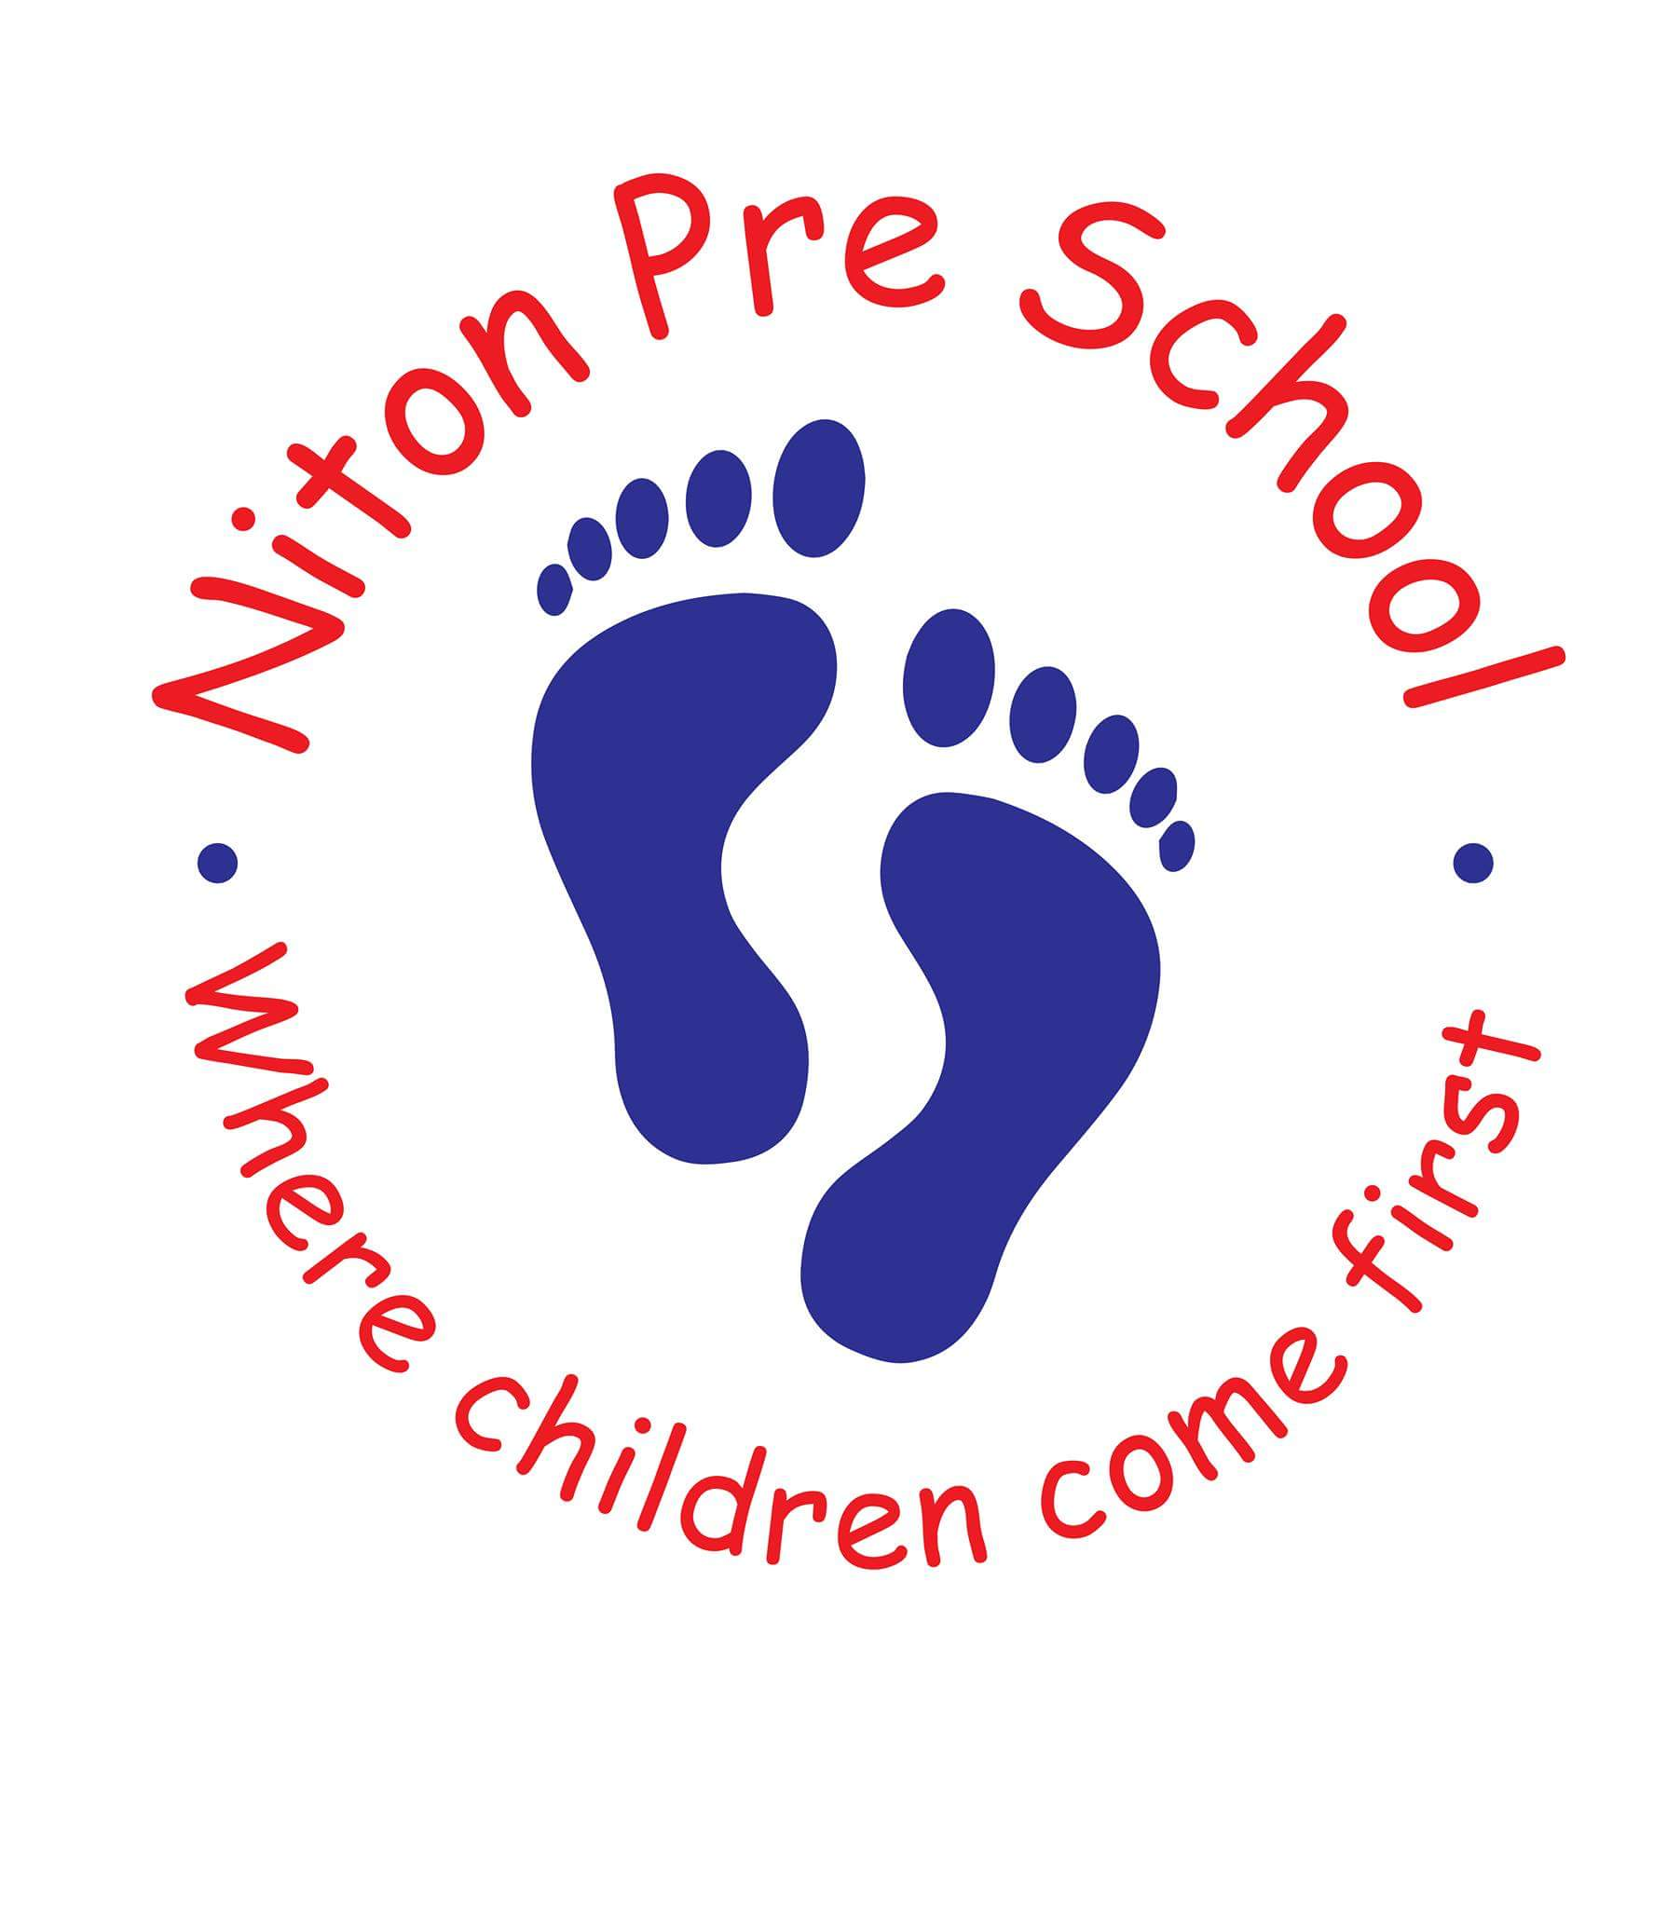
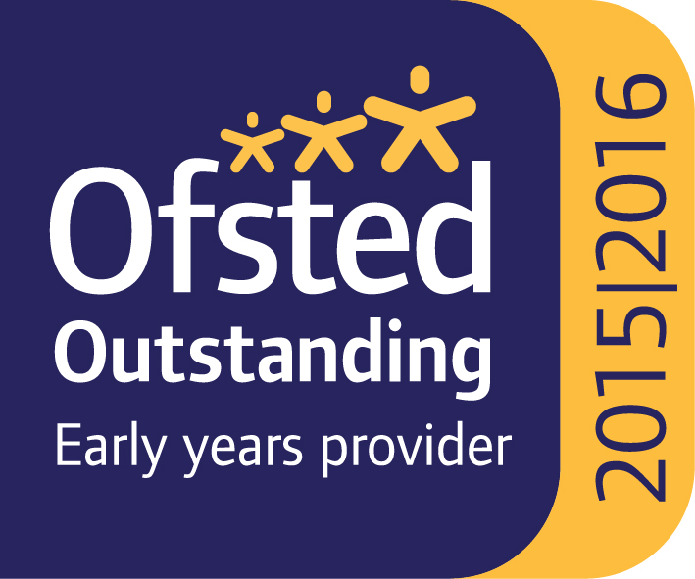


Niton Preschool Brighstone Preschool
School Lane New Road
Niton Brighstone
Isle of Wight Isle of Wight
PO38 2BP PO304BB
Tel: 01983 730985 Tel: 07707319843
Website:www.nitonpreschool.co.uk Website: brighstonepreschool.co.uk
E-mail:nitonpreschool@googlemail.com

Registered Charity No: 1100496

In September we are going to carry on running the following provisions:
- The Breakfast club will run from 7.30-8.30 am and breakfast of toast or cereal will be provided.
There will be a charge of £3 per child.

- After School Club will run from 2.45 -5pm
There will be a charge of £4 per hour

If any of the information you provided on your registration form has changed please let us know at the beginning of term.

Please fill in the form below and return it to preschool (by the end of term) or you can contact us by text or email.

Please may we also politely remind you that we need children to be booked into our clubs in advance, so that we can sort out our staff/child ratios. You can call or text us on 07707319843

I would like to book my child in to breakfast club;

Monday | Tuesday | Wednesday | Thursday | Friday

I would like to book my child in to After School Club;

Day | Monday | Tuesday | Wednesday | Thursday | Friday
Time of collection

Signed..............................................print name............................................... parent of.......................................................

