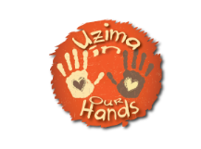

Dear Parent,

Uzima In Our Hands is a UK charity based on the Isle of Wight (charity number 1153181) that supports Uzima Orphan Day Care Centre which is based in rural Western Kenya. It helps orphans and the very poorest children in this very deprived area to get an education, food and medical care.

Every year a group of Island volunteers visits the day care centre and they use this visit to equip the children with essential resources. Two years ago sweatshirts were kindly donated by Carisbrooke CofE Primary School parents. As you can imagine they have been well worn ever since. Having their own identity by wearing a matching uniform meant so much to them, and now we want to go one step further and supply something NEW and with their OWN logo. These children have never had a brand new uniform since starting school.

WE NEED YOUR HELP
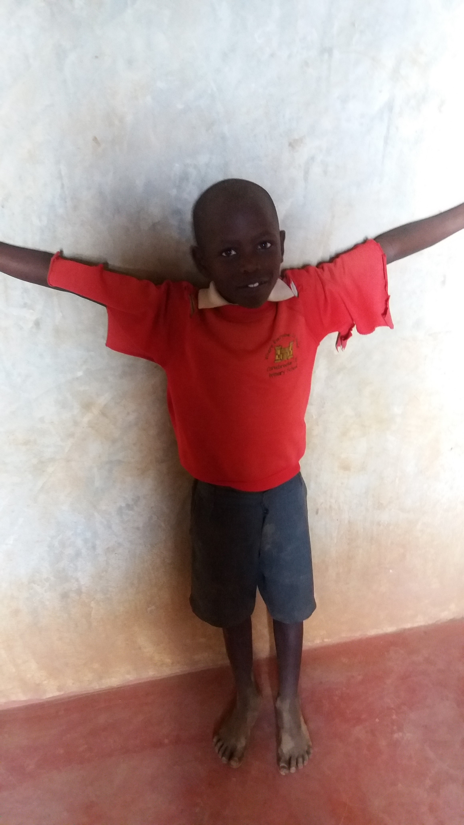
Big Wight T-Shirt have been very kind and agreed to be the supplier for these sweatshirts and we are asking if at this time when you are buying your
child's new school uniform at Big Wight T-Shirt if you could donate a further £6.95 whilst in the shop which would buy a sweatshirt for a child in Uzima.

Alternatively any donations towards this project will be gratefully accepted, and 100% of the donation will go to the orphans. You can buy a sweatshirt in 2 ways either in store at Big Wight, or on the charities website www.uzimainourhands.org, there is also a charity pot in store too.

To find out more about Uzima In Our Hands charity please go to www.uzimainourhands.org

