We are having a
‘Phil’ the Bag
fundraising collection!

- Everyone is welcome to take part.

- Please use any type of bag, black sacks are best! Or why not fill up an old pillow case..?

- The more we weigh, the more we pay.

- Please fill the bag with your unwanted clothes, shoes, household linen, belts, hats and handbags.



Our ‘Phil’ the Bag Recycle Day is on

Tuesday 21st March 3.00-7.30 p.m. OR before 10.00 a.m. on Wednesday 22nd March in our School Hall
_________________________________________________________________________________

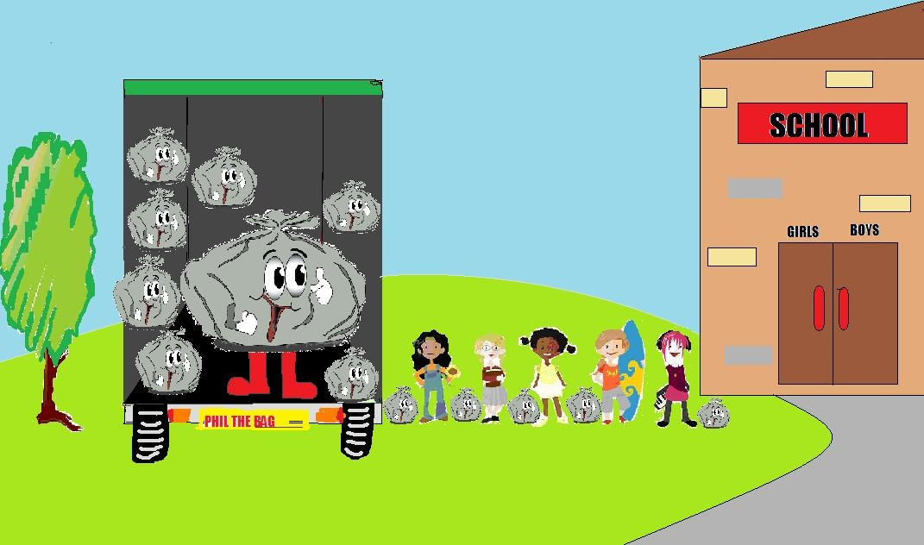

Don’t forget to bring in your bags of unwanted clothing, bags & shoes!

www.philthebag.co.uk

