**Spooky Half Term Fun at Newport Roman Villa**

Newport Roman Villa will be holding two family activity days during October half term. Entry will be just £1 per person to include entry and all activities. No booking required just drop in between 11am – 3pm.

**Monday 24 October, 11am – 3pm – Spooky Skeleton Clay Day**

Come and take part in our Spiders, Rats and Bats photo hunt and make your own spooky skeleton clay creation to take home.

**Wednesday 26, October 11am – 3pm – Horrid History**

Come and discover more about the darker side of Roman life and complete the nasty Newport Roman Villa trail. Make your own Roman purse and charms to take home.

Events organised by the Isle of Wight Heritage Service.

Newport Roman Villa, Cypress Road, Newport, PO301HA. (01983 529720) [museums@iow.gov.uk](mailto:museums@iow.gov.uk)

[www.iwight.com/museums](http://www.iwight.com/museums)

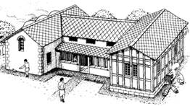

**Corina Westwood** | Curator Human History | Isle of Wight Heritage Service | Isle of Wight Council | Guildhall | High St | Newport | Isle of Wight PO30 1TY

Tel; (01983) 823433 | Email: [corina.westwood@iow.gov.uk](blocked::mailto:corina.westwood@iow.gov.uk) | Web: [www.iwight.com](http://www.iwight.com)