Go… Wild About Wight!

Wonders of the East Wight - Family Art Workshops!

Join artist Hannah George for the first of our free family arts sessions
exploring the unique and wonderful features of the East Wight!

The dates for your diary are Monday 8th August at Ryde Library, George Street, Ryde
&
Monday 22nd August at Branstone Farm, Branstone

We'll be making things inspired by the East Wight's natural and built heritage
as well as its rich flora and fauna.

Drop in anytime from 10am-12.30pm.

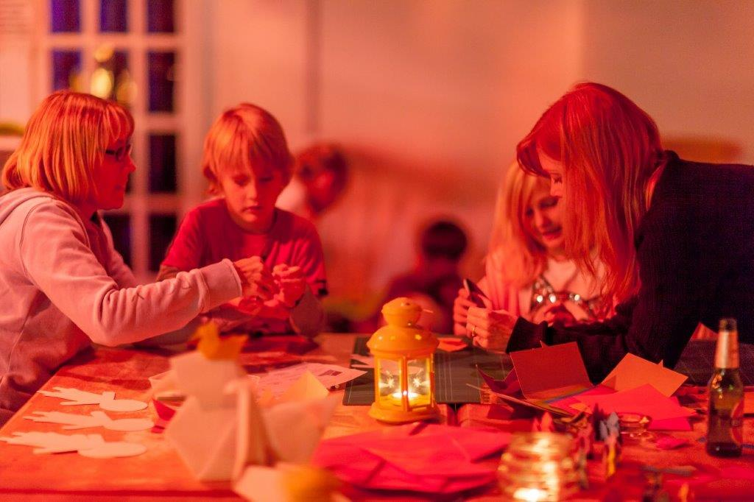

This is a FREE Wild About Wight/Down to the Coast event (Children must be accompanied by an adult)

For more information, contact maria@vectishousing.co.uk or find us on Twitter: @VectisHA, @downtothecoast and Facebook: Down To The Coast and Natural Wight.

(PS. Thanks to Julian Winslow & Shaping the Bay for the photo)

