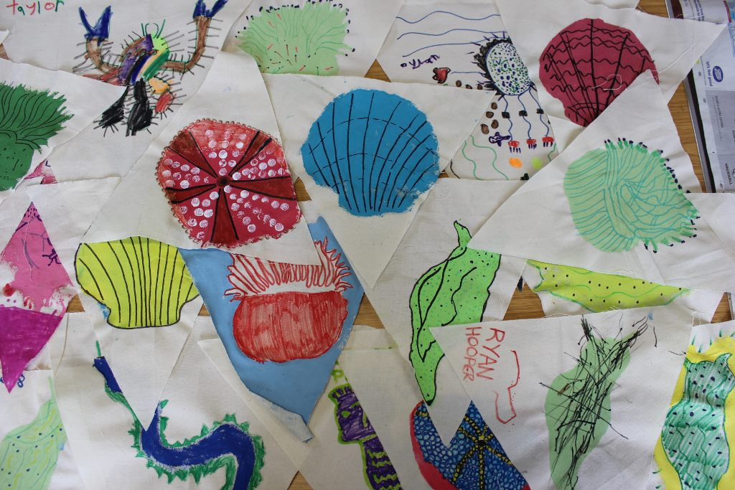

Under the Pier – there’s a whole world out there!

Ryde Pier Decoration Days

Bring some magical marine life to Ryde Pier for this year’s Under the Pier!

On Friday 2nd September, we’ll be out under Ryde Pier exploring the amazing marine life that’s made its home on the pier struts and in the sand. In the run-up to the big day itself, join our art workshops with artist Ian Whitmore and help create the longest bunting yet - a splash of sea creature celebration and colour to decorate the Pier!

Here’s where and when….

Thursday 4th August 2-4pm
East Cowes Vectis Neighbourhood Day (Vectis & Spectrum residents)
The Pavilion, Vectis Road, East Cowes

*
Saturday 6th August 11am-1pm
Under the Pier Decoration Day
Ryde Library, George Street, Ryde

*
Tuesday 16th August 11am-2pm
Wroxall Vectis Neighbourhood Day (Vectis & Wroxall residents)
The Tea Station, Shademakers HQ, Castle Street, Wroxall

*
Tuesday 23rd August 11-1pm
Under the Pier Decoration Day (Sewing Volunteers required!)
Ryde Library, George Street, Ryde

These are free events - all materials, paint and sea-creature inspiration provided!
For more information about this and more ways to go Wild About Wight and Down to the Coast,
contact Claire@vectishousing.co.uk or Suzie@vectishousing.co.uk, find us on Twitter: @VectisHA, @downtothecoast and Facebook: Down To The Coast and Natural Wight

