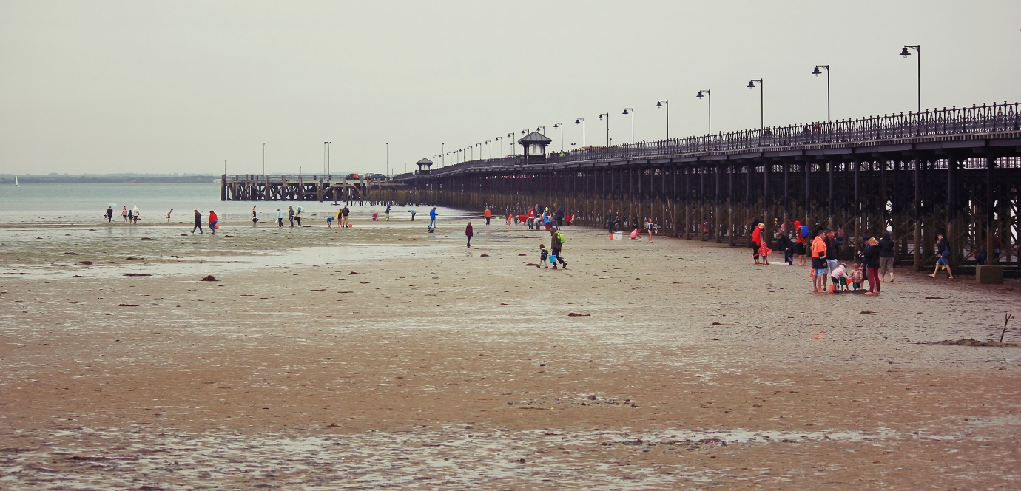

Under the Pier 2016!

There’s a whole wild world out there…

Marvel at a Sponge Garden! Meet an Anemone! Be amazed by the stars on a Star Ascidian!

Friday 2nd September 4.30pm – 6.30pm

Why are barnacles brilliant? What make a sea squirt squirt? Find out the answers with Arc, Vectis Housing and Friends as we discover the amazing array of marine life living under the famous Ryde Pier. Sand-pooling and marine species recording, Artecology beach art, listening to the sea… all sorts of ways to explore more!

West side of Ryde Pier – find us at the entrance to the beach on the green at the bottom of Union Street & St Thomas Street, Ryde

Bring a net and a bucket if you have one and make sure to wear wellies or waterproof shoes. Expect to get a bit splashed!

This is a FREE Wild About Wight/Down to the Coast event but donations for Hampshire & Isle of Wight Wildlife Trust are welcome. (Children must be accompanied by an adult)

Grid ref: SZ 59286 92985 Nearest bus stop: Ryde Esplanade

For more information, contact claire@arc-consulting.co.uk or Claire@vectishousing.co.uk or find us on Twitter: @arcteam, @VectisHA, @downtothecoast and Facebook: Arc Consulting Isle of Wight, Down To The Coast and Natural Wight. www.arc-consulting.co.uk/upcomingevents

