
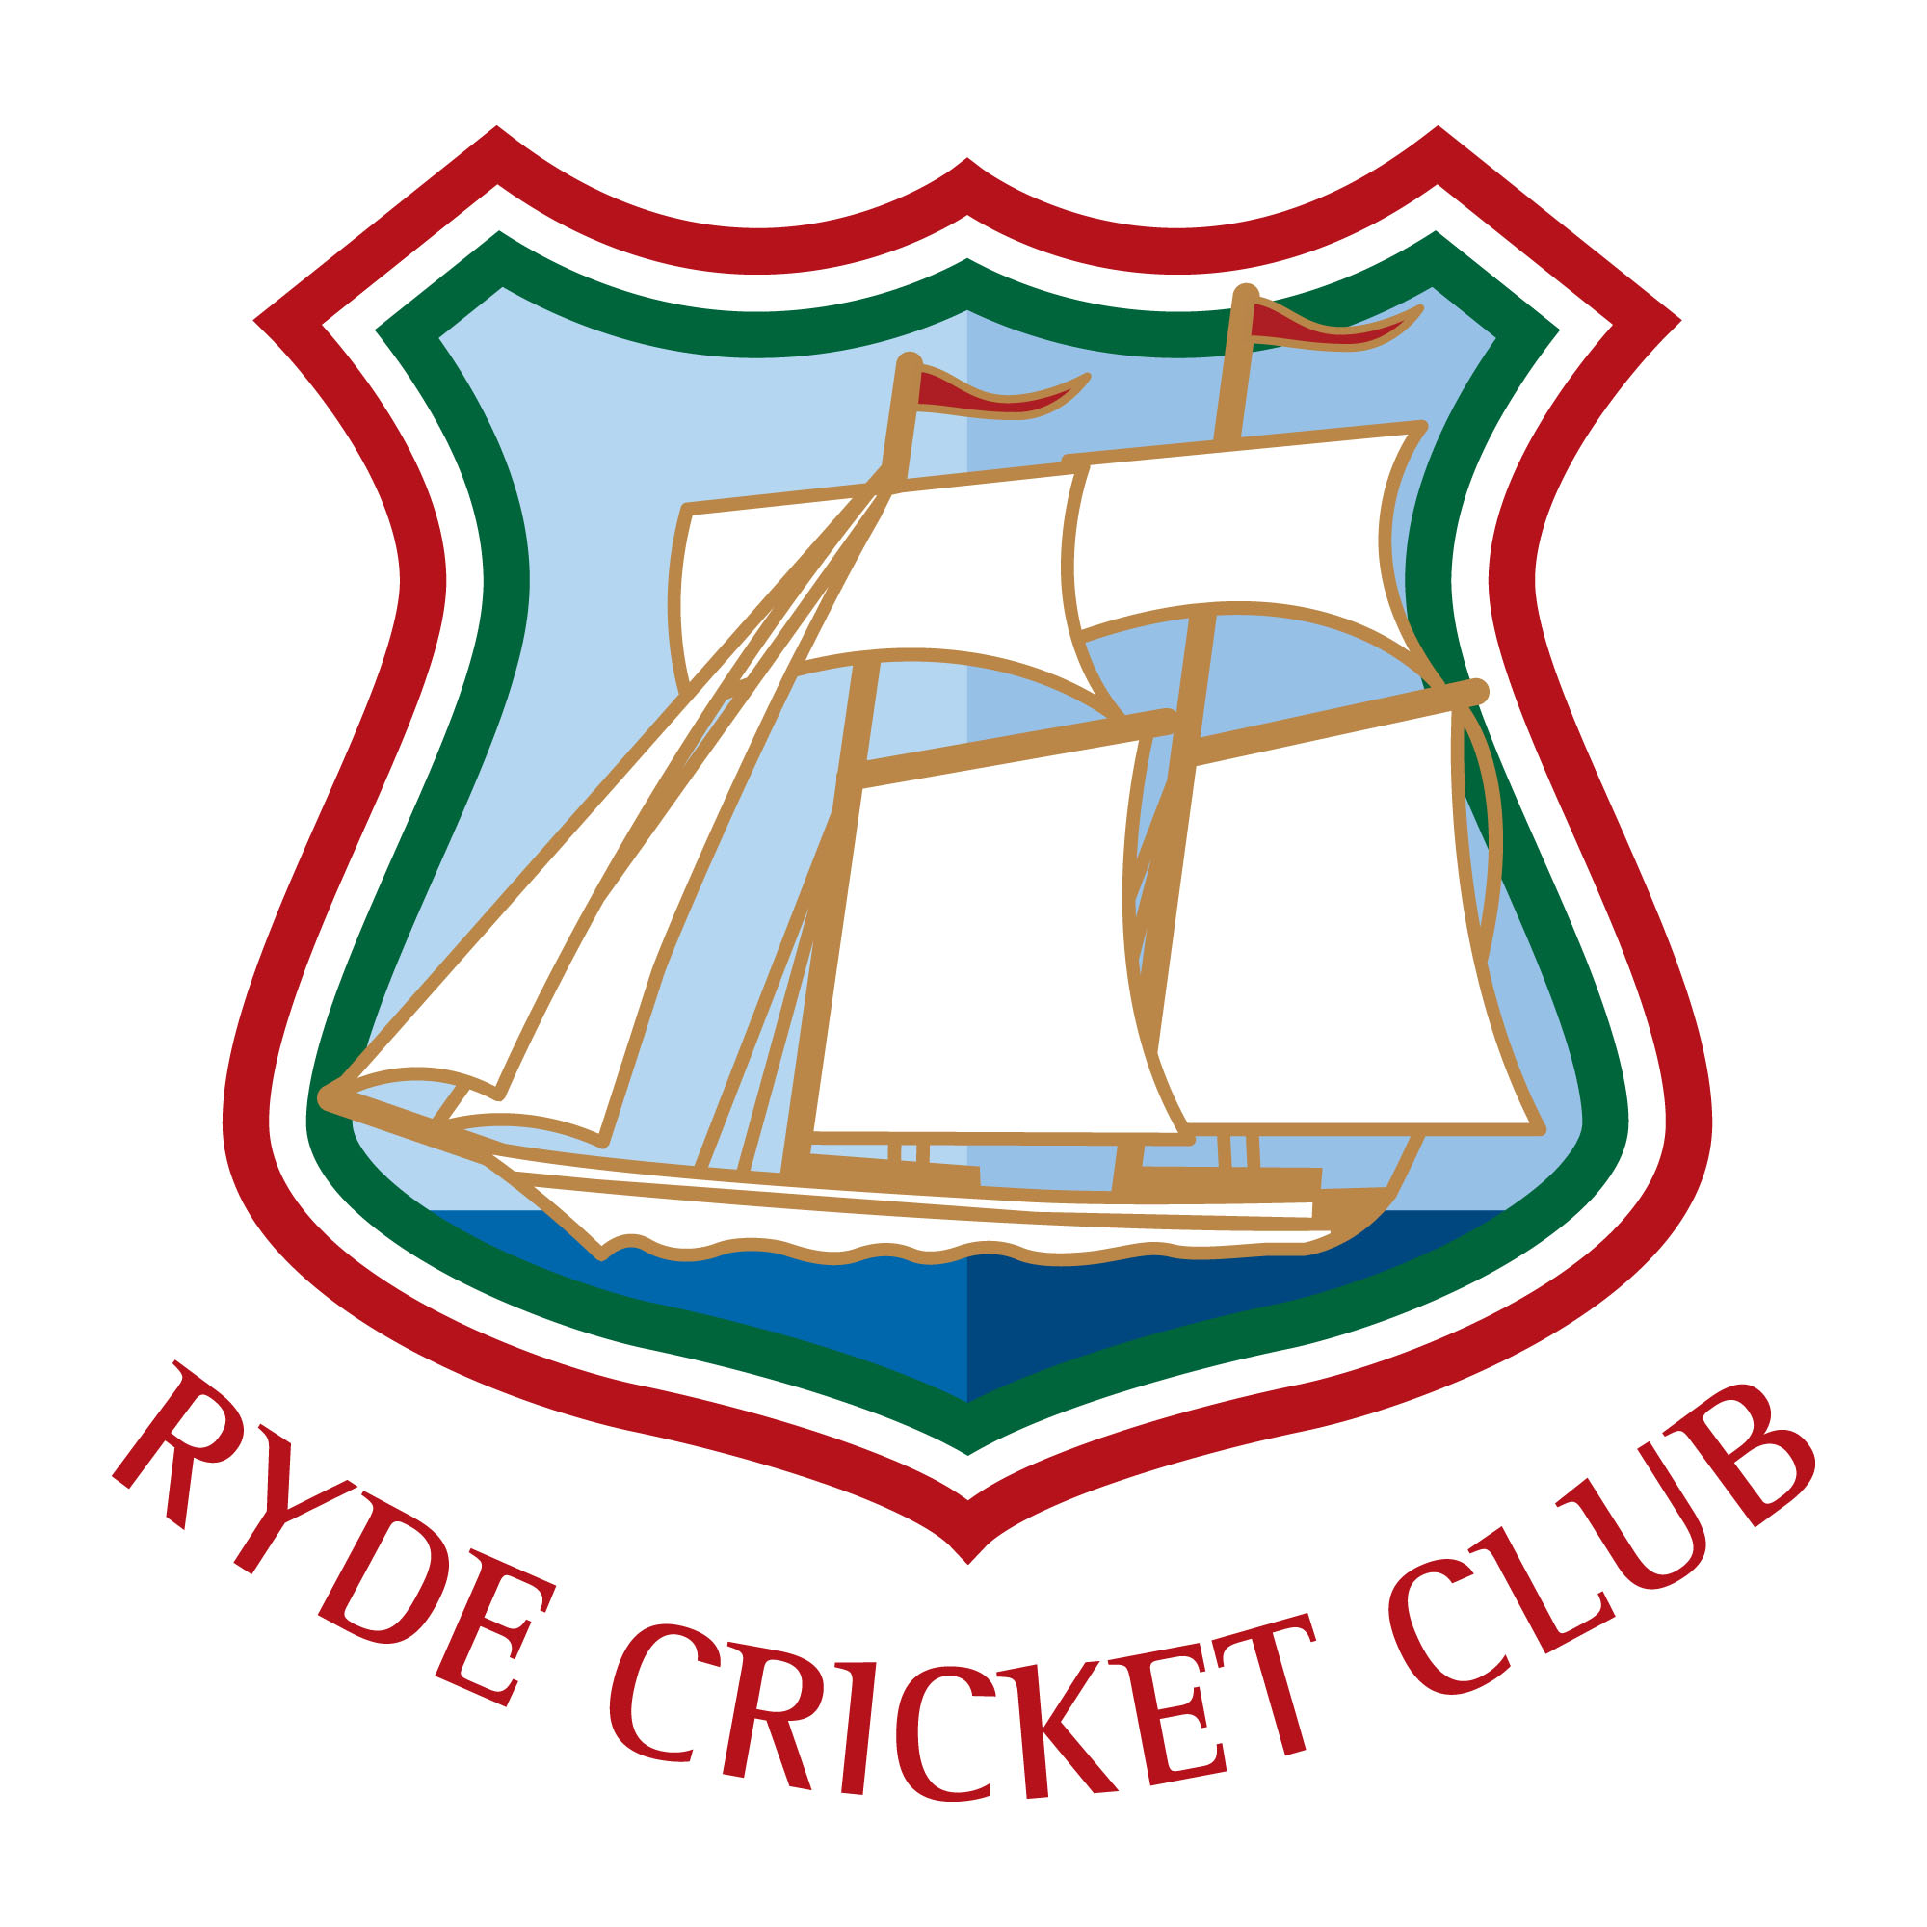
Ryde Cricket Club Open Day
Harding shute, Brading Road
(just past the Tesco roundabout)
Saturday 23rd July 9.30‐11.30
Come and find out about Ryde Cricket Club
FREE EVENT
- Try our cricket skill challenges ‐ batting, bowling, fielding.
- Prizes for the best score for U8, U9, U10, U11, U13, U15 and Adult.
- Refreshments, Raffle and much more.
- Stay and Watch Ryde CC 1st XI against Hursley Park in the Hampshire Southern Premier League Division 3
- For more information contact Gayle Trevallion 07779964407 or just turn up

We have a team for everyone ‐three colts team, 2 Saturday adult teams, a Sunday team, a 49ers and a midweek XI

