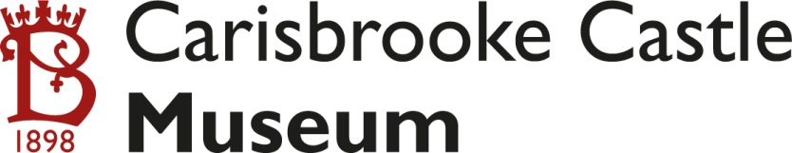
Museum Insights
Summer Programme 2016
Burhs and Beacons: The Defence of the Wihtlande in the Viking Age
A talk on the defence of the Isle of Wight in the later Anglo-Saxon period, with a detailed consideration of the archaeology at Carisbrooke Castle. Come and hear arguments that the lower enclosure at the Castle is actually Roman in origin.
Speakers: Landscape historian John Margham, with contributions from archaeologist David Tomalin
Saturday 30th July 9.30am at Carisbrooke Village Hall, followed by a ‘field study’ at Carisbrooke Castle until 12.45pm *
-----
Who put the boing in Zebedee?
This session will look at the inventive work of Hooke, particularly relating to springs. We will see just how important his invention was, by considering objects in the Museum collections.
Speakers: Local scientists Nick Minns and Graham Petrie
Saturday 10th September 10.30am-1pm

Tickets for each Museum Insight: £8 including tea, coffee and biscuits
*£6 for IWNHAS members for the July talk
For further details and to book your places please ring 523112
or e-mail info@carisbrookecastlemuseum.org.uk
BOOKING IS ESSENTIAL as places are limited.
Museum Insights are arranged to give local people opportunities to find out more about the museum and its collections
Museum Insights
Summer Programme 2016
Burhs and Beacons: The Defence of the Wihtlande in the Viking Age
A talk on the defence of the Isle of Wight in the later Anglo-Saxon period, with a detailed consideration of the archaeology at Carisbrooke Castle. Come and hear arguments that the lower enclosure at the Castle is actually Roman in origin.
Speakers: Landscape historian John Margham, with contributions from archaeologist David Tomalin
Saturday 30th July 9.30am at Carisbrooke Village Hall, followed by a ‘field study’ at Carisbrooke Castle until 12.45pm *
-----
Who put the boing in Zebedee?
This session will look at the inventive work of Hooke, particularly relating to springs. We will see just how important his invention was, by considering objects in the Museum collections.
Speakers: Local scientists Nick Minns and Graham Petrie
Saturday 10th September 10.30am-1pm

Tickets for each Museum Insight: £8 including tea, coffee and biscuits
*£6 for IWNHAS members for the July talk
For further details and to book your places please ring 523112
or e-mail info@carisbrookecastlemuseum.org.uk
BOOKING IS ESSENTIAL as places are limited.
Museum Insights are arranged to give local people opportunities to find out more about the museum and its collections

