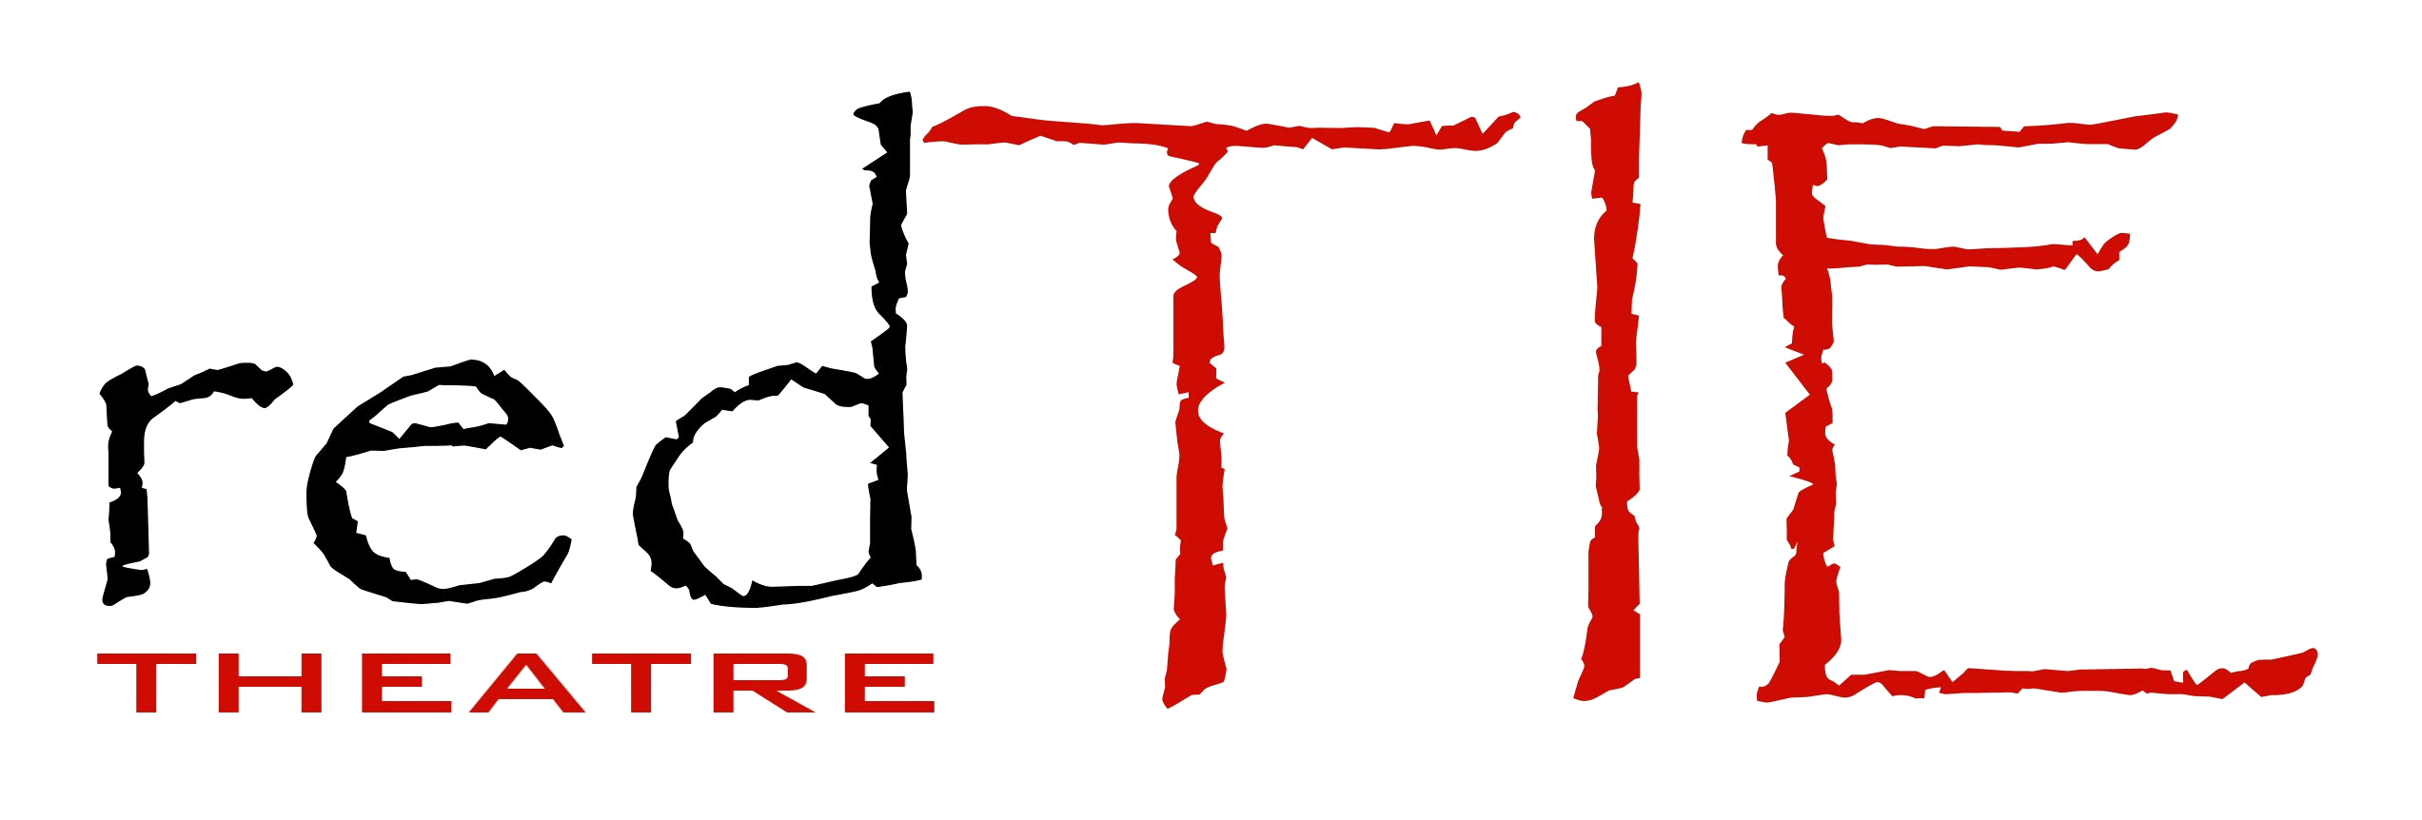

Drama Summer School for 9-13 years
Gurnard Primary School Baring Road
1st -5th August
10am – 3pm
£60 for 5 days (or £15 a day)

Drama Summer School for 13-18 years
Apollo Theatre, Pyle St. Newport
22nd- 26th August
10am-3pm
£60 for 5 days (or £15 a day)

Sunday workshops
Starting September 18th 2016.
At Unity Hall Newport
9-13 years 12-2pm
13-19 years 10am – 12
£50 per 10 week term

www.redtietheatre.co.uk redtietheatre@hotmail.co.uk
23 Staplers Rd. Newport. PO30 2DB Tel: 01983 533432 or 0771 2050 920

