PARENTS VOICE IW
Your Local Forum for Parents and Carers of Children and
Young People with Special Educational Needs and Disabilities.

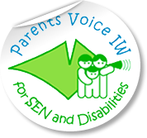
COFFEE MORNING

THURSDAY 30TH JUNE
09.30 – 12.30

Bebeccino Café

14B High Street,
Newport. PO30 1SS
(Opposite County Hall)

0930 – 1230

Please come along to our Coffee Morning to meet other parents and our team for a friendly chat, coffee and support.
This coffee morning’s focus will be on communicating with your child.
We will have a guest speaker to introduce you to Makaton signing and explain how it can help.

Parents Voice IW, Isle Help Centre, 7 High Street, Newport. PO30 1UD
Tel: 01983 823898 ext 2838 email: parentsvoice@peoplematteriw.org

