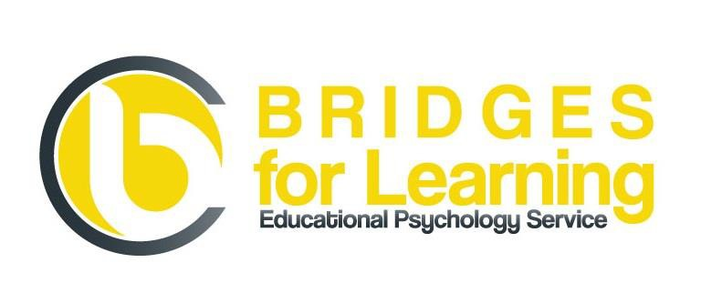

Summer Holiday Ready?

Mindfulness session for parents of children with SEND
(No charge)

Bridges for Learning Plus CIC (Educational Psychology) continues to be committed to providing free training for parents of children with SEND.
This year we are offering a pre-summer holiday session on Mindfulness.
It will be a purely practical session with lots of ideas for you and your children.

Friday 8th July 2016
10.00-11.30 am
Quay Arts Centre
Seminar Room

To book a place please email contactb4l@gmail.com or complete on-line form on our website www.bridges4learning.co.uk

