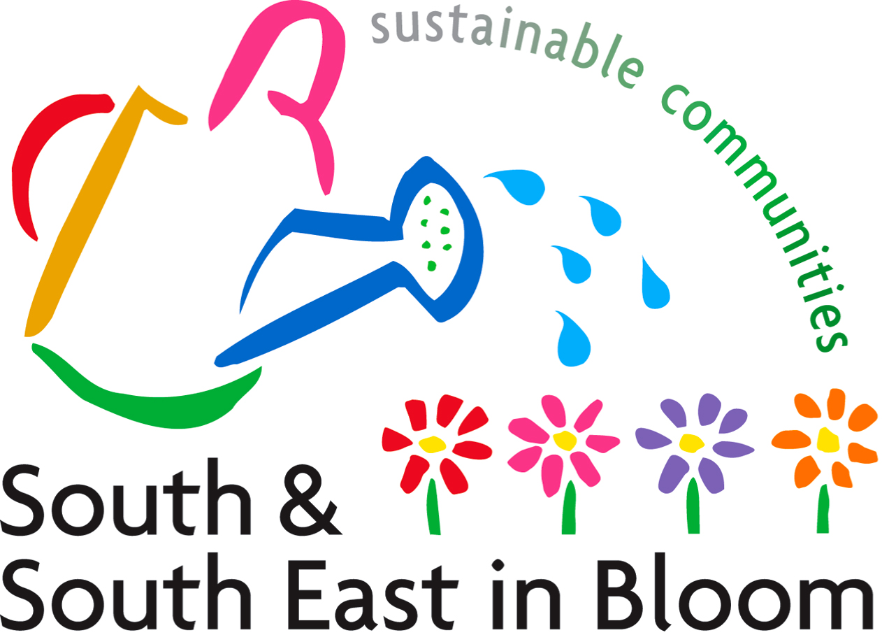

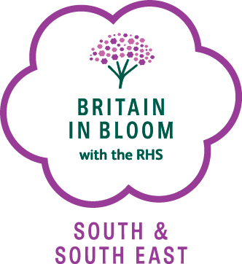

Children’s Art Competition 2016

100th anniversary of Roald Dahl’s birth/150th anniversary of the birth of author Beatrix Potter

Entry Application Form

Please photocopy, complete details in BLOCK CAPITALS and affix to the back of EACH entry.

Name of School………………………………………………………………………..
Address…………………………………………………………………………………
…………………………………………………………………………………………..
…………………………………………………………………………………………..
Tel………………………………………………………………………………………
E-Mail…………………………………………………………………………………..
Name of School Contact……………………………………………………………….

Name of Artist………………………………………………………………………….

Entry Category (Please tick appropriate box)

1. Foundation Years 3. Key Stage 2

2. Key Stage 1 4. Key Stage 3

Please send completed forms and entries to:

South & South East in Bloom Children’s Painting Competition
124 Gravel Hill
Croydon
CR0 5BF

Closing date for entries 13th May 2016

Please post entries flat, not in rolls.

Children’s Painting Competition 2016
South & South East in Bloom promotes the benefits that trees, shrubs, plants and flowers, water and wildlife make towards the environment and we would like the art work to in some way reflect this.

Competition themes
This year’s themes are
100th anniversary of Roald Dahl’s birth/150th anniversary of the birth of author Beatrix Potter
Designs can be in any art medium, i.e. paint, drawing, collage, computer generated, photograph etc.

Key stage Entry Categories

1. Foundation Years 3. Key Stage 2
2. Key Stage 1 4. Key Stage 3

Prizes
Each Key Stage category winner will receive a £25 Garden Centre Voucher and the overall winner will receive a £50 Garden Centre Voucher for use at your school. All entrants will receive a certificate

Competition Rules
Paintings/Graphics

- No wording on the painting or graphic
- Unaided work only
- Maximum size of A4

Entries

Schools may submit no more than 5 entries per Key Stage.
- Entries can only be submitted by a school (not individually).
- Details of the school, artists/designer name and age, and entry category must be affixed on the reverse side of each entry in BLOCK CAPITALS (see application form).
- Entries must be received no later than 13th May 2016
- The decision of the judges is final and no correspondence will be entered into.
- South & South East in Bloom reserves the right to use the winning entries in the promotion of the South & South East in Bloom Competition without obtaining permission.
7. Please enclose a stamped addressed envelope if you require the entry to be returned.

