Write stories and make books!

Learn a class poem to perform in front of the whole school!

Book swap shop – bring in a book to swap with your friends!

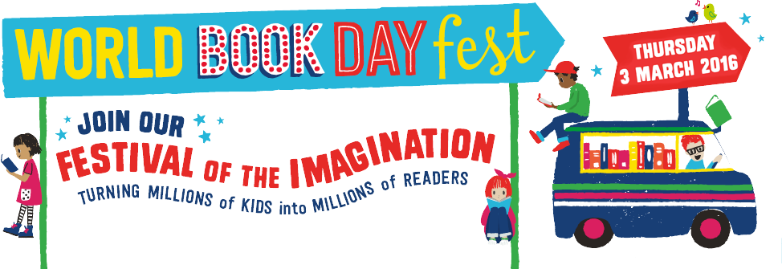

Collect hints and tips from famous authors as they share their writing secrets online!

Dress up as your favourite book character and raise money for Book Aid International!

Take part in the Family Book Quiz – win a prize!