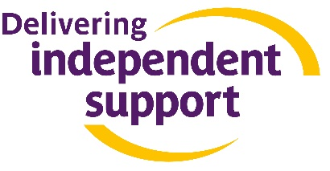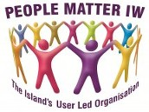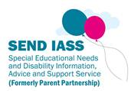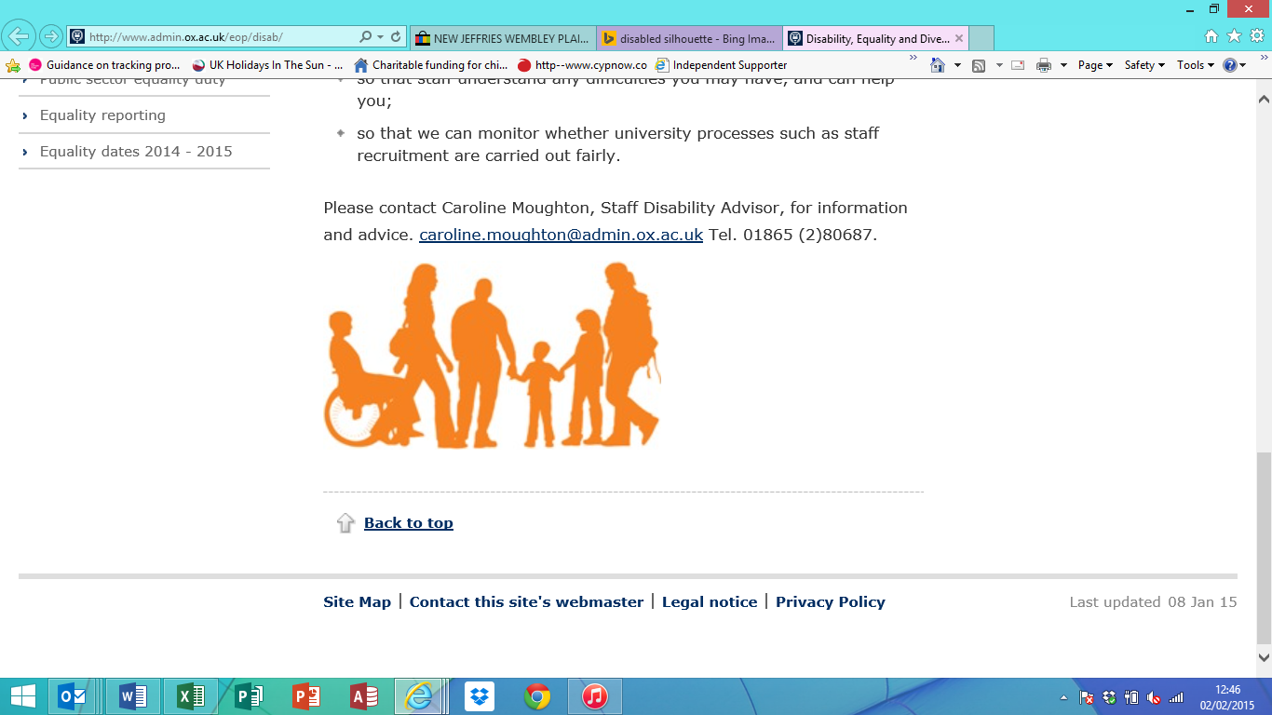

**Free workshops for Parent Carers of children and young people with Special Education Needs and Disabilities!**

The Independent Support Programme, co-ordinated by SENDIASS and People Matter IW, are running a series of information workshops to help parent carers understand the Special Education Needs and Disabilities system.

The next workshop focuses on SEN Support and will look at how those who don’t have an EHCP should be supported and what the new Code of practice says.

If you would like to come along please contact: SENDIASS on 01983 825548 or email [sendiass@iow.gov.uk](mailto:sendiass@iow.gov.uk)

Advice, guidance and support for parent carers & children and young people with Special Education Needs and Disabilities on the Isle of Wight

**Future workshops and dates:**

* **EHCP and Personal budgets - 11th February 2016**
* **Making sense of SEND outcomes -10th March 2016**

**Understanding SEN Support Workshop: Supporting children and young people without an Education, Health and Care plan.**

**January 21st 2015**

**10.00 am until 12.00pm**

**At Carisbrooke College, Mountbatten Drive, NEWPORT, PO30 5QU**