Bridges for Learning Educational Psychology Service

Free Training Event

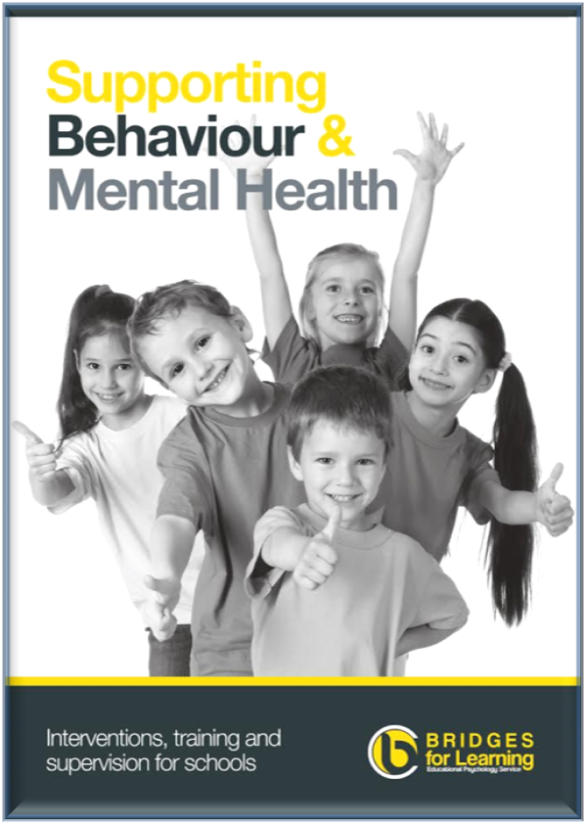
We have just launched our brochure which is packed with a choice of services that we provide to support Behaviour and Mental Health in children and young people.
Please come along to our free event and pick up a copy anytime from 10.00-12.30

Friday 5th February 2016, 10.00-12.30

Quay Arts , Seminar Room ( off the café)

Attachment Friendly Classrooms training 11.00-12.00 (no charge)
E: contactb4l@gmail.com w: bridges4learning.co.uk

