**AgeUKIW Drop-in sessions** are held at:

**The Exchange, New Road, Brighstone** from **10 – 12noon every Wednesday**

**Island Cottages, 1 Taylor Court, The Green, Shorwell** between **10 – 11am every Monday .**

Pop in to chat to your local Community Development Officer, Judith Stratton, about remaining independent in your own home or other issues that are part of later life. **If you are interested in finding out more about any of the above or have ideas for other activities please contact Judith Stratton AgeukIW Community Development Officer on 525282 or email**[**judith.stratton@ageukiw.org.uk**](mailto:judith.stratton@ageukiw.org.uk)

**Terry’s Wednesday Coffee Mornings –** If you enjoy getting together at our Tuesday coffee mornings why not give Terry’s Wednesday coffee morning a go too? Don’t be shy, new people are always welcome to pop in for a friendly chat.

13th May, 10 – 12 noon - Dorothy Clark, 31 Ashley Way, Brighstone

27th May, 10 – 12 noon - Terry and Paul, Barlands, Limerstone

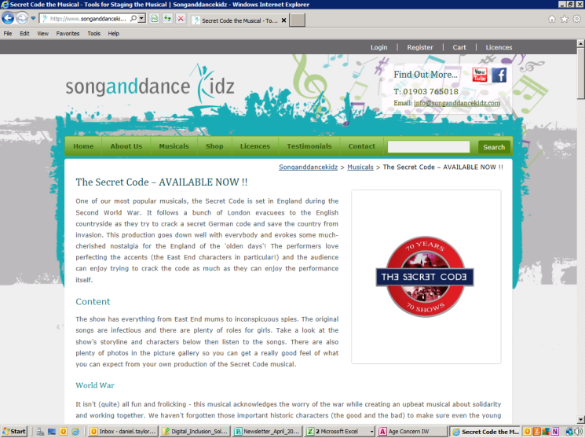If you fancy hosting an occasional coffee morning please call Terry Fisher on 740456.

**South Wight Youth Theatre**  - will be staging a musical callecalled **The Secret Code’** at **Shorwell Village Hall on 9th May at 7:30**. This is part of a world record attempt with 70 productions of the play being performed simultaneously across England, Canada and America to commemorate the 70th anniversary of the end of World War II. The play is set in England during the Second World War and follows a group of London evacuees as they try to crack a secret German code to save the country from invasion. Essentially this is a comedy but it isn’t (quite) all fun and frolicking - it acknowledges the worry of war while creating an upbeat musical about solidarity and working together. Tickets are £6 (Adults) £4 (children) will be available on the door.

**May 2015**

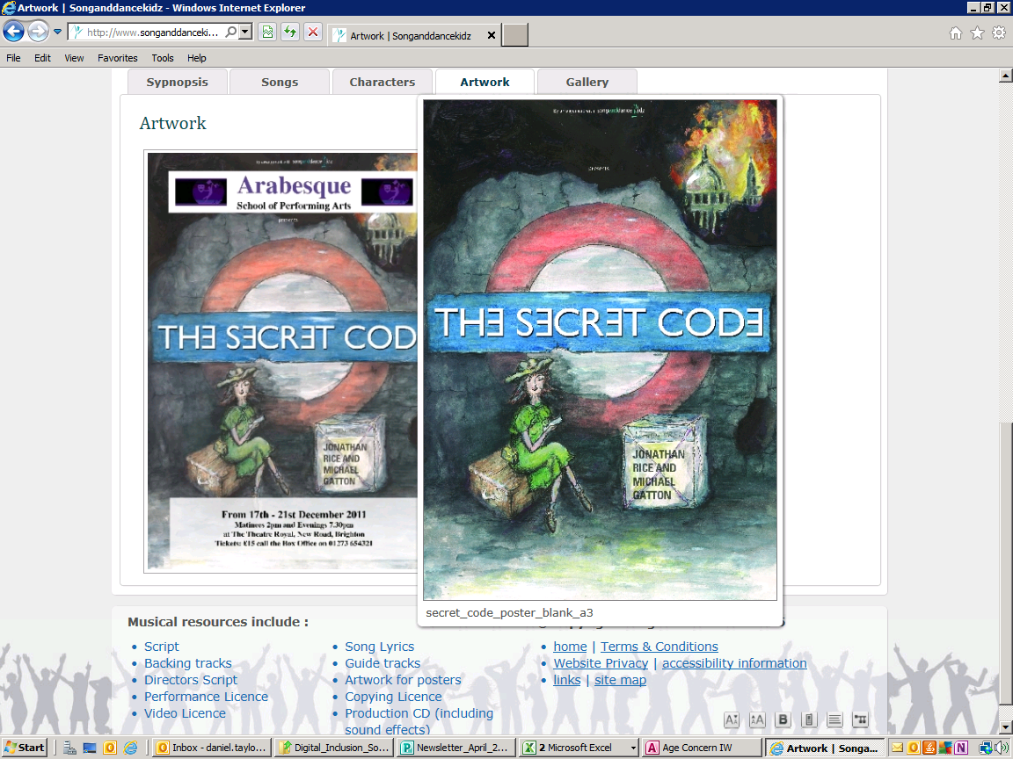**Look Inside!**

**Community Coffee Morning**

**Every Tuesday**

**from 10 – 12 noon**

**Methodist Church**

**Brighstone**

**Coffee Chatter Friendship**

**Hand massages Quizzes**

**Visiting organisations**

**Fun!**

***The Brighstone Community Coffee Morning is a partnership event coordinated by AgeUKIW, the Methodist Church, Brighstone and the Church of England***



**Community Coffee Morning**

**Quiet Room at the Coffee Morning** Please note that for those of you who have difficulty hearing or would like to talk to a smaller group of people, the **Wesley Room is available** every week (accept the first week of the month) **for a quiet chat**.

**5th May – CAKE WEEK!** Feel free to bring in a cake to share with your friends! **‘Action on Hearing Loss’** will be in the Wesley Room.

**Books –** Marlene will be bringing in books for sale to help us raise funds, if you have books you would like to add to her sale table please bring them along.

**Computer help –** David will be on hand to offer IT & mobile phone support.

**12th May – No Coffee Morning this week.**

**19th May – Sue Carr from The Alzheimer’s Society** will be paying us a visit. Are you interested in finding out more about **Alzheimer’s** from either a personal viewpoint or that of a carer/friend/family member? Then come along and chat to Sue.

**26th May – Computer help –** David will be on hand to offer IT & mobile phone support.

If you would like a representative from a particular organisation or charity to visit the coffee mornings please let Judith Stratton know and we will do our best to get them to come along.

**‘Pitch up at the Pub!’** AgeUKIW are hosting coffee mornings **every Friday at The Crown Inn, Shorwell from 10:30 – 12noon**. Pop in for a chat and try their delicious coffee and cake for just £2. There will also be the opportunity to receive **Help with your computer –** We are lucky to have an AgeUKIW volunteer living in the area who is available to help people get the most from their computers, lap tops and iPads. She can offer help with general problem solving, online shopping, email, Skype, safe surfing of the net, how to recognise scam emails and using social media such as Facebook and Twitter.

‘**Wight Seated Exercise’** are at the **Methodist Chapel, Brighstone every Thursday from 10 – 11am, cost £3.50.** This exercise class is designed to strengthen all parts of the body without you even getting out of your chair. Suitable for all ages and abilities, just work at your own pace and within your body’s limitations. This is the most fun you will ever have sitting down! For more information contact Paul Fifield on 07527956971 or email info@wightseatedexercise.com

**New Dance Class for Mature Movers! Every Thursday, 10.15-11.45 at the Scout Hut, Brighstone (term time only).** Following a successful taster session organised by AGE UKIW, Michelle Hainsworth, is starting a new class in Brighstone. Michelle’s sessions are designed to be fun, social activities where people get together and do gentle dance exercises. They can help improve your co-ordination, muscle strength, balance, breathing and memory. Come along and have a go. Price £4 including refreshments. (First lesson free).

**New Table Tennis Club –** we are in the process of setting up a Table Tennis Club to run one evening a week at the Village Hall, Russell Road. If you are interested in joining or have any unwanted table tennis equipment that you are willing to donate please contact Judith Stratton on 525282.

**Red Cross Falls Prevention and Equipment Loan Service** volunteer Lorraine Skipper will be visiting **The Exchange on 20th May from 10am – 12 noon.** Pop by andtalk to her if you would like to learn more about the service and take the opportunity to try out some of the gadgets that can help you maintain independence in your own home.