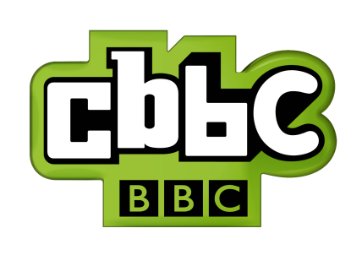
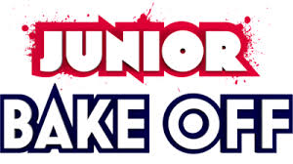
…IS LOOKING FOR BRITAIN’S BEST YOUNG BAKERS.

Does your child love baking and fancy putting their skills to the test? Can they make the most mouth-watering shortbread; are they potty about pies or simply bonkers about bread?

CBBC is looking for junior bakers aged between 9 -12 years across the country to take part in the brand new

All parents/guardians please visit: http://thegreatbritishbakeoff.co.uk/applications/ for an application form.
For Enquiries:
Email: juniorbakeoff@loveproductions.co.uk
Tel: 0207 067 4858
@juniorbakeoff

Terms and Conditions of Entry: All applicants must be between the ages of 9 and 12 years as of 10th August 2015. All completed applications must be sent back to us by midnight Sunday 10th May. The programme will be filmed over a period of 6 days during August 2015. All applicants must be resident in the UK. Any child with immediate members of their family or members of their household who are employees/directors/agents of either the BBC or Love Productions are not eligible to appear on the programmes or participate in the application process. All applicants must be accompanied by a parent or a legal guardian at the audition and during filming. Submission of an application form and compliance with the above terms does not in any way constitute an offer to appear on the programme. The Production Team’s decisions regarding selection to the programme are final.

