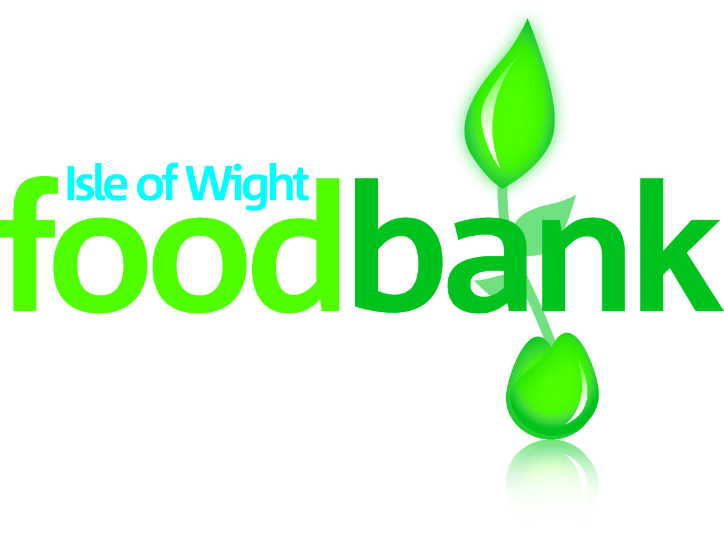

Pre-loved Clothing
For sale
Saturday 2nd May
10am - 1pm

At the foodbank Centre:
LOVE LANE, COWES, PO31 7ET

Come along for great quality, BARGAIN second-hand clothes and textiles, together with unique handmade crafts and…
Tea, Coffee, Cake and Tombola

#TurningFashionIntoFood
Visit our website:www.isleofwight.foodbank.org.uk
e: info@isleofwight.foodbank.org.uk t: 01983-292040

