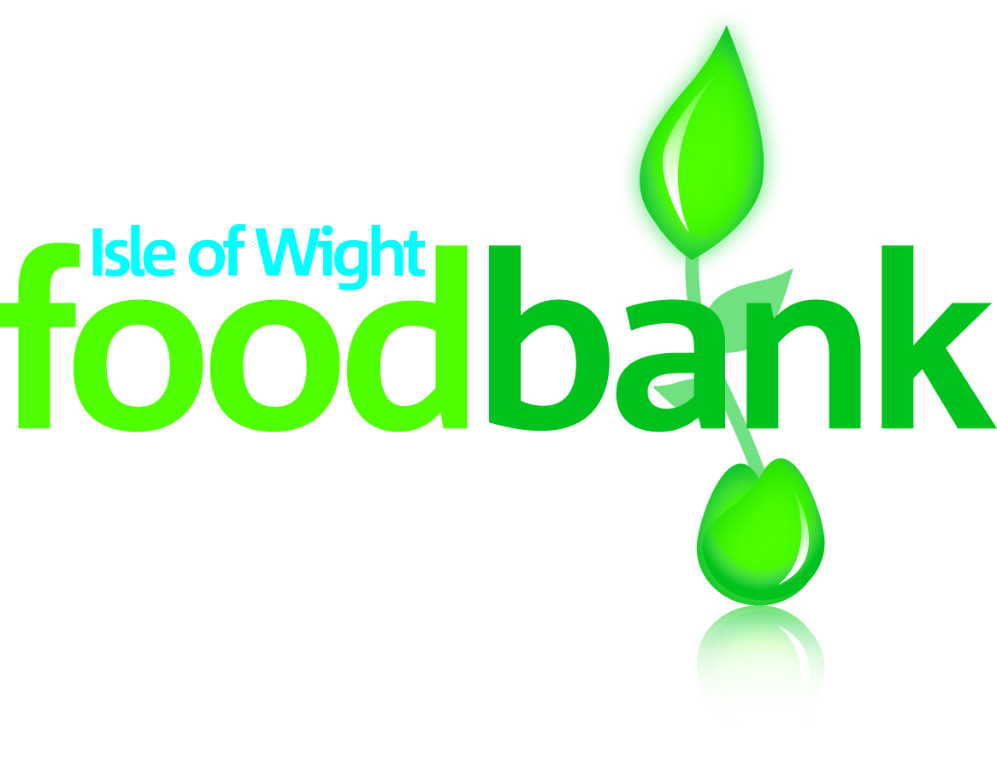
*SEASONAL*
*CLEARANCE*
*SALE*

Pre-loved Clothing
& Textiles
Saturday 7th March
10am - 1pm

At the foodbank Centre:
LOVE LANE, COWES, PO31 7ET

Come along for great quality, BARGAIN second-hand clothes together with unique handmade crafts and…

Tea, Coffee, Cake and Tombola

#TurningFashionIntoFood

Visit our website:www.isleofwight.foodbank.org.uk
e: info@isleofwight.foodbank.org.uk t: 01983-292040

