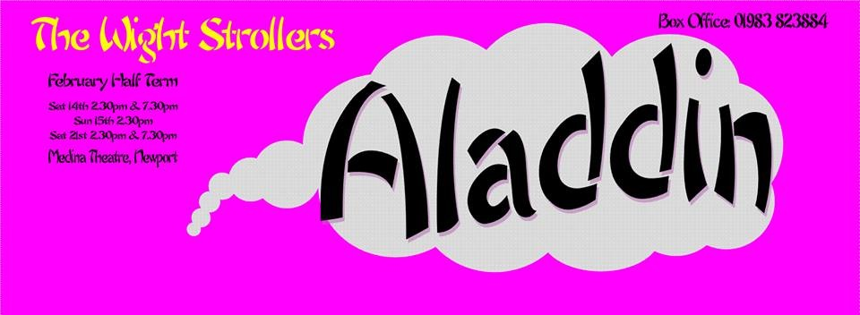

**"Professional quality at amateur prices!"**

Need to entertain the kids at half term? Looking for something a bit different to do on Valentine's Day? Or maybe you just want to see a spectacular of music, laughter, love and colour...

[The Wight Strollers](https://www.facebook.com/pages/The-Wight-Strollers/287615674615745) are performing 'Aladdin' at Medina Theatre this half term:

Saturday 14th Feb - 2:30 and 7:30pm

Sunday 15th Feb - 2:30pm

Saturday 21st Feb - 2:30 and 7:30pm

Tickets are £7.50 for adults, £6.50 for juniors.

**IN AID OF ISLAND CHARITIES - this year, Defibrillators in Public Places and the IW Prostate Cancer Support Group.**

Tickets can be bought from Medina Theatre Box Office in person, by phoning 01983 823884 or by visiting: [http://www.medinatheatre.co.uk](http://www.medinatheatre.co.uk/article/wight-strollers-pantomime-0).

Don't miss out, it's a show that's guaranteed to entertain the whole family!