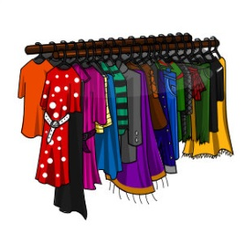
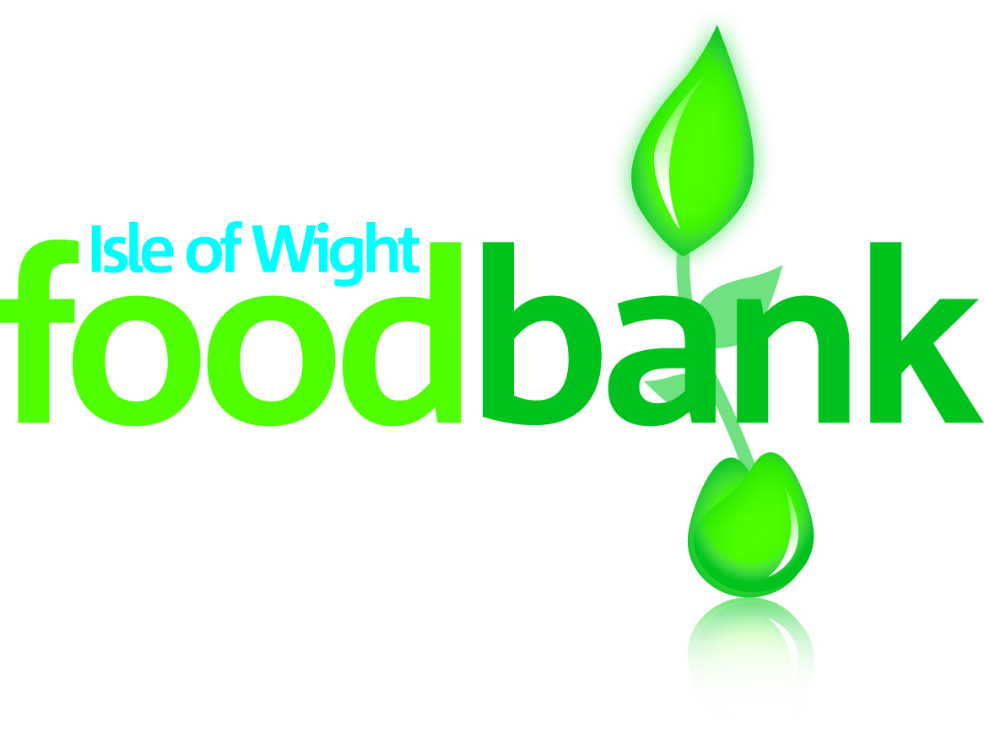
Pre-loved Clothing
& Textile Sale
Saturday 7 February
10am - 1pm

Held at the foodbank Centre:
LOVE LANE, COWES PO31 7ET

Good quality, brand named, second- hand clothes
Tea, Coffee and Cake, Tombola
Turning Fashion into Food
For more information visit our website: www.theisleofwightfoodbank.com

Or contact the office on 01983-292040

