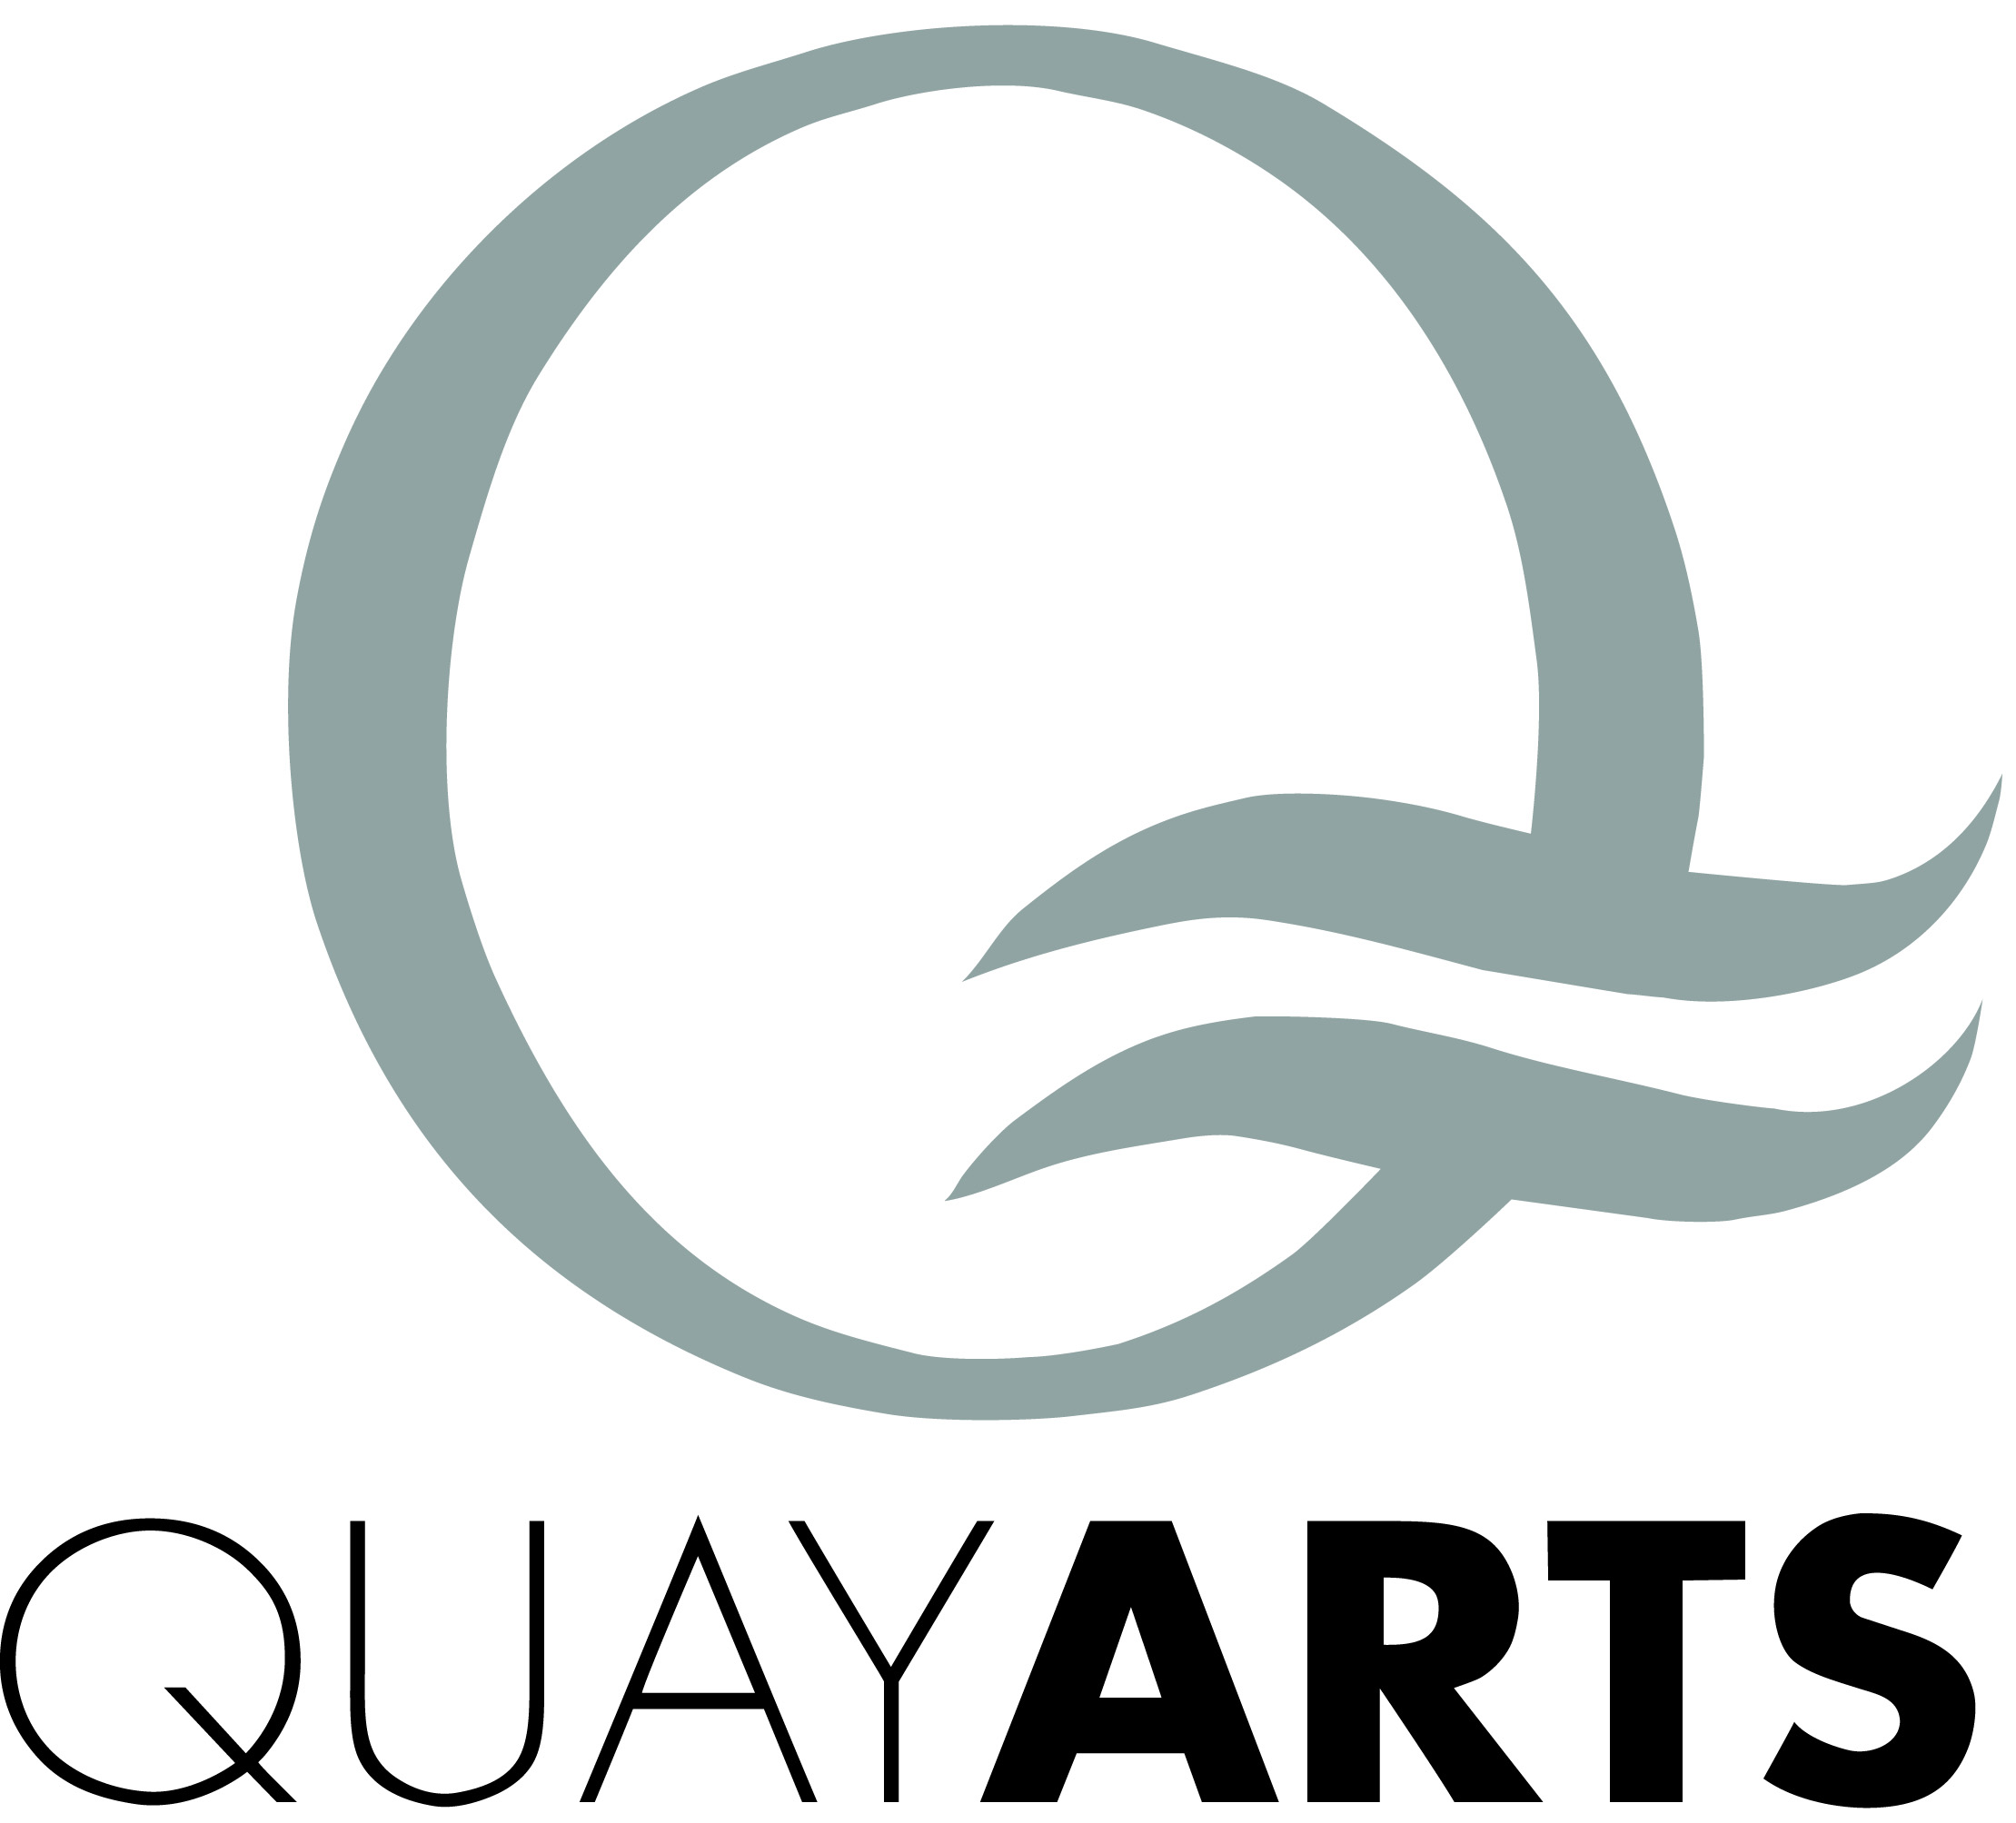
Kids’ Art Jan – Mar 2015

Saturdays 10am – 12pm
Term ticket £45 or £6 per session

17 Jan Shadow Play with Jo Johnson
Explore imagery and puppetry inspired by Jenny Clayden’s wonderful exhibition.

24 Jan Peg People with Hannah George
Paint, clothe and house little characters all made from the humble wooden peg.

31 Jan Cool Collage with Ian Whitmore
Rip, cut and stick pictures from magazines to create your own crazy scenes.
Materials provided, but feel free to bring along magazines and photos.

7 Feb Composite Creatures with Chris Jenkins
Using metal, wood and composite clay to create a sculpted army of creatures.

14 Feb FREE Valentine’s Day Family Drop-in with Ian Whitmore supported by the Daisie Rich Trust, 10am – 1pm Come and join in this fun activity to spin-paint valentine hearts!

28 Feb Still Life with Jo Johnson
An innovative mixed media session using intriguing objects to create still life drawings.

7 Mar Nature Drawing with Hannah George
Practice your skills and techniques drawing from beautiful natural objects like seeds, leaves and flowers.

14 Mar Guitar Assemblage with Chris Jenkins
Craft a unique guitar sculpture from found materials.

21 Mar Spring books with Ian Whitmore
Make handmade concertina books to fill with tree, flower and bug art exploring Spring time!

28 Mar Stitchery with Jo Johnson
Bring your drawings to life using colourful wools and threads.

For other Kids’ classes, Dancing Tots, Drama with RedTie Theatre, Pottery
and Rob da Bank’s Music Club, please see our website www.quayarts.org

TO BOOK, CALL BOX OFFICE 01983 822490 (or book online)

