- Home
- Walks
- General Info
- Galleries
- Sponsors
- Contact us
- Competitions
- News
- Travel
- Island Trails

Welcome to the official website of the Isle of Wight Walking Festival 2014
Gentle
Moderate
Brisk

The Isle of Wight Walking Festival - Award Winning Event
The Isle of Wight Walking Festival is a proud winner of the:
The Beautiful South Awards for Excellence 2010 for Tourism Best Event (SILVER)
The Tourism of ExSELLence Award for Best Event 2009 (SILVER) and
The CIPR Award for Best Event 2009 GOLD
Click on image below to view programme
or to download ....

It has been reported that the Autumn Walking Weekend was a HUGE success, and we experienced an

amazing October - the weather was perfect! A BIG thank you to all Walk Leaders for supporting the event, and of course to all of our "Sponsors & Supporters"

We look forward to next May! Programme is being compiled as we speak. If you wish to have a hard copy which will be available in February, please email elaine.cesar@iow.gov.uk to request a copy.

ISLE OF WIGHT WALKING FESTIVAL 2015 DATES ANNOUNCED
2 - 17TH MAY 2015

Isle of Wight Walking Festival 2013 Video

CLICK HERE TO SEE MORE VIDEOS

Isle of Wight Challenge 2 - 3 May 2015
28/11/2014
Autumn Walking Weekend - Great Success
05/11/2014
WALKING FOOTBALL - IW Sports Unit
22/10/2014
Subscribe to our RSS News feed
Distance:
Pace:
Difficulty:
Date:
16TH ISLE OF WIGHT WALKING FESTIVAL PROGRAMMES AVAILABLE NOW! FESTIVAL PACKED WITH BRILLIANT WALKS AND ACTIVITIES - PUT THE DATES IN YOUR DIARY NOW!! 3 - 18 MAY 2014.
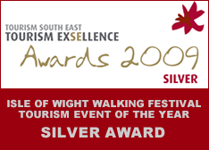
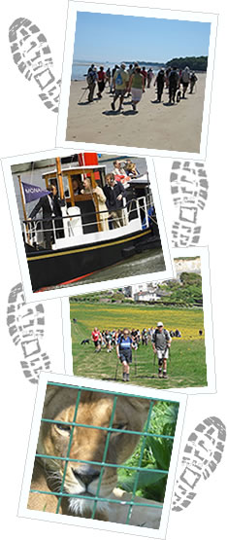
- home
- Walks
- General Info
- Galleries
- Sponsors
- Contact us
- Competitions
- News
- Travel
- Island Trails
Isle of Wight Web Design by Matrix e-Business
- Copyright
- Privacy Statement
- Subscribe to our Newsletter

