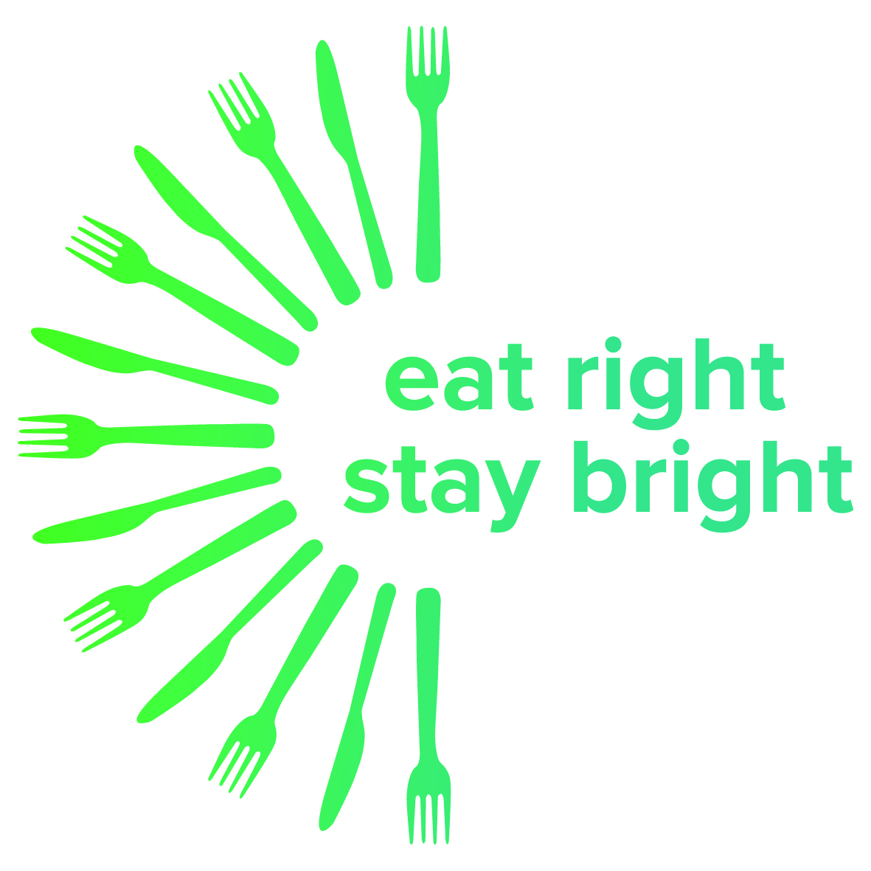
Hints and Tips

The Eat well plate makes healthy eating easier to understand by giving a visual representation of the types and proportions of foods people need for a healthy and well balanced diet.
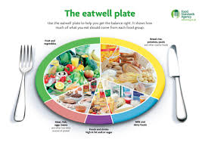
Eating a healthy, balanced diet is an important part of maintaining good health.

Eat lots of fruit 5 a day

Eat more fish

Eat less salt

Cut back food and drink high in fat and sugar

Drink plenty of water

Don’t skip breakfast

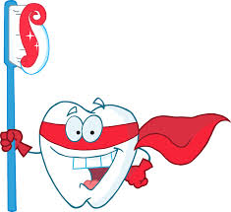
Oral Health 1 Reduce the frequency of sugary foods and drinks to less than 3 or 4
Times a day
2 Brush teeth with fluoride toothpaste, particular before bedroom
3 Children UNDER 7 years old be supervised when brushing their teeth
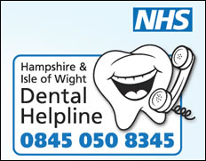
4 A pea sized blob of toothpaste is needed: just a smear of toothpaste for very young children
5 Spit Don’t Rinse
6 Visit the dentist at least once a year:
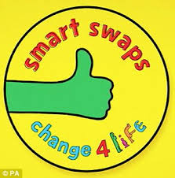
Have you seen the new TV advert on Sugar Swaps!
Change 4 Life is helping families cut back on SUGAR SWAPS with a free sugar swap pack, including a sugar swaps guide, money-off vouchers & more

- Sign up and make sure you don’t miss out on your fabulous free pack
- Pick a swap that will help you cut down on the sugar your family eats
- To reduce the amount of sugar you & your kids eat throughout the day
You can log on at: https://sugarswaps.change4life.co.uk

