St. Mary’s Church, Brighstone
1st Brighstone Beavers, 1st Brighstone Cubs
1st Brighstone & Shorwell Brownies
1st Brighstone Scouts 1st Brighstone Explorers
1st Brighstone & Shorwell Guides
Amnesty International Alzheimer’s Society Alzheimers Café
Bangkok Refugee Tree (Thailand)
Brighstone Bellringers (Bell tower Display)
Brighstone Grange Residential Home
Brighstone Library Brighstone WI
Brighstone Primary School Trees (two trees)
Cameo Cystic Fibrosis Trust
Christ the King College Earl Mountbatten Hospice
Five Churches Christian Aid Group
Freshwater Flower Club
Healthwatch IoW
IoW Law Society IoW Parkinson’s Society
IoW Caledonian Society Isle of Wight Pearl
IoW Motor Neurone Assoc IoW Scout Jamboree – Japan 2015
Independent Arts
Island Cooling Engineering IoW Foodbank
IoW Guild of Weavers, Spinners, and Dyers
Island Professionals IoW Multiple Sclerosis Society
St Mary’s Hospital - Juba Hospital Link
Love Russia Monday Prayer Group
Medina House School Mitchelmore Family Naomi House
Northwood Primary School
- Lunchtime Gardening Club
Philip Crewe Ryde Chorus
St Mary’s Handbells St Mary’s PCC
St Mary’s Sunday School (Kid’s Sunday Club)
St Saviour’s RC Choir Totland
The Children’s Society
The Royal British Legion
Wessex Cancer Trust Support Centre
West Wight Floral Art Society
YMCA Young Carers
“7” Café and Bistro
The Three Bishops
1-2-1 Hairdressing IoW Pathways
IoW Street Pastors IoW Women’s Refuge
Freshwater Bay Golf Club
Memorial Ploughing Match
Neighbourhood Police
Rutherford Eye Care
Semi Colon Support Group
The Five Bells Art Group
The Living Room The Three Bishops Trees
Ventnor Lions Green & Forster Veterinary Surgeons

FESTIVAL EXHIBITORS

”She wrapped him in cloths and placed him in a manger, because there was no room for them in the inn”.

Brighstone Methodist Church
1st Brighstone & Shorwell Rainbow Guides
Open Doors - Age UK (IOW) Action for Children
Action on Hearing Loss Brighstone Methodist Church
Brighstone Pre School Brighstone Village Art Group
Cruse Bereavement Care Carisbrooke Priory
Cuddly Bears Club Freshwater WI
Grange Farm
Holy Cross RC Primary School. East Cowes.
IW Breast Screening
Niton Pre School Phoenix Project The Quakers
Teddies for Tragedies
The Anthony Nolan Cancer Trust
The Donkey Sanctuary World Peace Flame

Brighstone Library
A selection of mini trees decorated by children.
And outside ....
Brighstone Church - The Hospice Tree
Courtesy of J.R.Buckett & Sons.
The Methodist Church -The Tree of Light
Courtesy of Isle of Wight Pearl.
The Wilberforce Hall - The Parish Council Tree
Courtesy of Brighstone Parish Council.
Mottistone Church – Courtesy of Shide Trees.
A big “Thank you” to all our sponsors
The IoW Pearl; J.R.Buckett & Sons; National Trust;
Shide Trees; Bookers; IoW County Press; Red Funnel;
Orchard Bros (Freshwater); Harvey’s of Yarmouth;
Brighstone Holiday Centre; B&Q; The IoW Beacon;
Signpost Express; Staples; Jewsons; Tescos Ryde Extra;
Sainsburys; Brighstone Parish Council; M&S; John’s Club;
Wightlink. Brighstone Horticultural Society; Morrisons;
Scarrotts Lane Bakeries; Southern Cooperative;
The Village Society for decorating the Wilberforce Hall,
West Wight Rotary Club for decorating the Hall Stage;
Sharon & Carol Matthews for decorating
St Mary’s Church Porch
With apologies to anyone we have inadvertently overlooked.

Mottistone Church
Bumble Bee Tree
Chessell Pottery Diabetes Centre
Freshwater Lace Friends of Uganda
Gideons International IoW College
John’s Club Historical Association (IoW)
Mottistone Gardens Newnham Family
Poetry Tree Relate
Saturday Club for Deaf Children
Southern Bells (Niton Handbells)
Scoliosis Assoc (UK) St Catherine’s School, Ventnor
SSAFA Stanley Family
Tea Gardens at Mottistone
The RNLI Huntington’s Disease Assoc.
Woodlands Yarmouth Guides
Brighstone Social Club & Reading Rooms
Arbonne Tree Brighstone Social Club Tree
Brighstone Health Walking Group
Brighstone Lawn Tennis Club
Brighstone Holiday Centre Community Action IoW
Flowers for You (Ventnor) Freshwater Central WI
Headway IoW
Island Free School
IoW Special Olympics
IoW Ambulance Service
IoW Fire & Rescue – Blue Watch.
Oxfam Patrick Hayes Decorating
Queensgate School The Piano Café
Vectis Decorative & Fine Arts
Wednesday Craft Fayre
West Wight Sports Centre
What Knot Crafts
Woodlands Trust Therapy & New Avenues Group
The Wilberforce Hall
Age UK The Red Cross RSPCA
1st Yarmouth Beavers & Scouts 11th Newport Guides
Brighstone & District Horticultural Society
Brighstone Village Society Carers UK
Canine Partners Check it out Group
Co-op Funeral Care Family Support
Chillerton Players Crafty Artists
Friends who Craft IoW Portage Service
IoW Morris Minor Owners Club
IoW Society for the Blind IoW Zoo
Lacemakers of the Wight National Autistic Society
Niton & District Camera Club Robert Hooke Society Sevenacres St George’s Special School
Wight Squirrel Project Wight Challenge
Wight Vintage
This event has been made possible thanks to the work of
many people. We hope you enjoy your time in
our villages. A big “Thank you” to all our
exhibitors, and to the many helpers who have
worked tirelessly to ensure your enjoyment of the Festival.
All proceeds will go to local and national charities.
Further Information at www.bxtf.org. E-mail chris@brighstone.org.
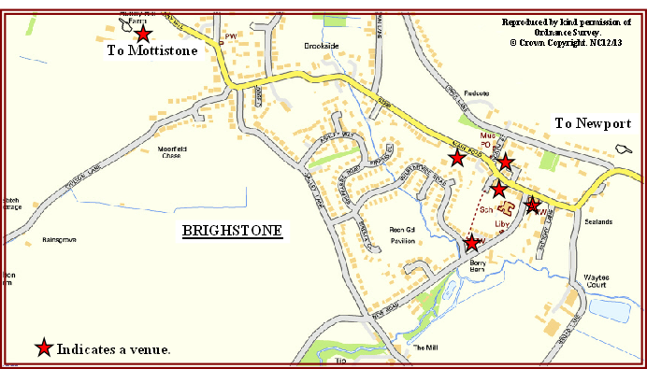

During the Festival enjoy refreshments

Thurs, Fri, Saturday – Wilberforce Hall; Sunday –Scout Centre
(NB. On Saturday Soup & Crusty Bread served 12 - 2.30 pm)
also in - The Methodist Church & The Social Club
The Three Bishops open all day from 10am
Mulled Wine & Roast Chestnuts …. “7” Café & Bistro.
Mulled Wine & Mince Pies - National Trust Shop, Mottistone – Sunday.11am to 3pm
* * * * * * * * * * * *
Winter BBQ-Mini Market.Craft Fairs-Handbell Ringing-Concerts
Mini Xmas Tree Displays in the Library-Carol Singing
Musical Entertainment-Lace making Demonstrations.

Wheelchair access at all venues - limited access at Mottistone
PARKING
In addition to street parking
Warnes Lane: Reading Rooms; Methodist Chapel in Brighstone;.
also National Trust Car Park in Mottistone
Please give precedence to disabled, and park safely and sensibly

Saturday & Sunday Dec 13th/14th only.
PARK & RIDE to and from
Brighstone Holiday Centre & IoW Pearl,
on the Military Rd to Brighstone
Methodist Church.
Missed the Festival? Don’t worry. Trees will remain in Brighstone Church & the Methodist Church until Boxing Day.

Christmas Celebrations in our Villages.

Wednesday December 10th:
7.00pm Hospice Tree Lighting Service - Brighstone Church
with Jo Blackburn CEO of Earl Mountbatten Hospice, Cllr Ian Ward
& Cllr Charles Chapman Chairman & Vice Chairman
Isle of Wight Council
Thursday December 11th:
3.30pm Carols with Brighstone Schoolchildren, and lighting of the “Tree of Light” by Cllr Bob Seely -- Methodist Church
Friday December 12th:
10.00am -4.00pm Christmas Gift & Craft Fair – Scout Centre
4.00pm Carols with “The Village Society” - Wilberforce Hall
7.30pm Christmas Carols Old & New with Combined Choirs
& Brighstone Belles – Brighstone Church.
Saturday December 13th:
1.00- 4.00pm Brighstone School Christmas Fair – at the School
2.30-3.30pm the Credorer Ensemble-
Seasonal Instrumental Music in Brighstone Church
2.30- 4.30pm Andrew Skinner Organist –Methodist Church
4.30pm Carols, crib blessing and hand-bell ringing with Niton Handbells in the presence of Claire Locke, Isle of Wight High Sheriff - Mottistone Church
Sunday December 14th:
2.30-3.30pm “Rhymes & Chimes of Christmas” - Brighstone Church
7.00pm Stars of Wonder Concert - Brighstone Church –
A musical extravaganza full of festive flavour and variety
in aid of island based charity “Love Russia”
Helping orphaned & abandoned children in Russia
Tuesday December 16th
1.00pm Brighstone School Christmas Play “Over by Christmas”
– Brighstone Church
7.00pm A Folkey Christmas Concert with The Slipshod Singers and
Brighstone Barnacles – Brighstone Church
Wednesday December 17th
6.00pm Brighstone School Christmas Play “Over by Christmas”
– Brighstone Church
Friday December 19th
7.30pm Carol Concert with Ryde Chorus – Brighstone Church
Saturday December 20th
7.30pm The fantastic and ever popular Military Band Concert
with Sandown & Shanklin Military Band
in the presence of Lt Col Sir Guy Acland Bt LVO DL
Proceeds in aid of ABF-The Soldier’s Charity - Brighstone Church

For details of Christmas services see www.fivechurches.org.uk

“For God so loved the world, that He gave His only begotten Son, that whoever believes in Him shall not perish, but have
eternal life”
WELCOME
to the
18th Brighstone Christmas
Tree Festival.

11th - 14th December 2014

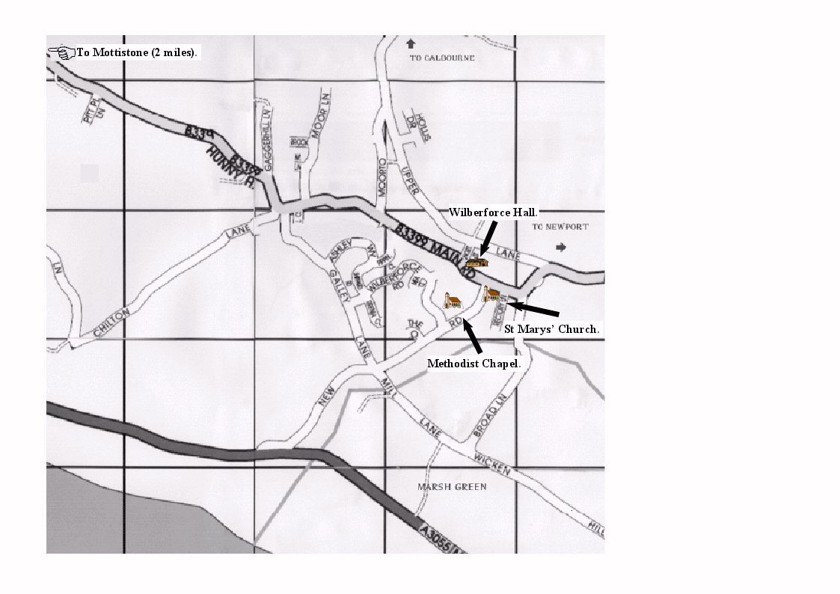

The Churches and Residents of Brighstone,
Hulverstone, Mottistone and Brook
extend to you a very warm welcome
to our Community.

We wish all visitors a very peaceful Christmas.
Thank you for your support

