

WE ARE ALL THINGS AUTUMN.
 | Thursday  23rd October | Friday  24th October | Monday 27th October | Tuesday 28th October | Wednesday 29th  October | Thursday  30th  October | Friday  31st  October
Time Required

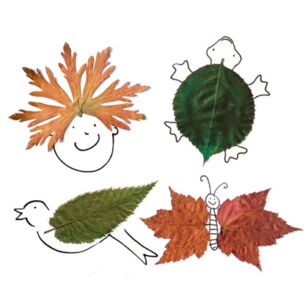
Please write the length of time that you require the booking for in the appropriate box and sign below, returning the booking form to school for confirmation of your booking. Thank You.
Booking times available:
8:30-12:45 - £10.
12:45-5pm - £10.
8:30-5pm - £20
6 hours (e.g. 9:30-3:30) - £15,
2 hour slots - £7
Amount charged for any additional hours or late collection booked: £4.00 per hour.
OFFERS: There is a 25% reduction for sending a 2nd or 3rd sibling for half the day OR a 50% reduction for sending a 2nd or 3rd sibling for the whole day OR buy 4 whole days and the 5th one free if you have one child.

Signed:_____________________________________ parent/ Guardian. Signed:_____________________________ Fab Staff

*Due to amount of places being booked and cancelled there is now unfortunately a charge of 50%
of the payment for any cancellations.

