The Piano Café presents…
Stars of Tomorrow

Music by the Bay

A Musical Afternoon featuring
local young pianists:
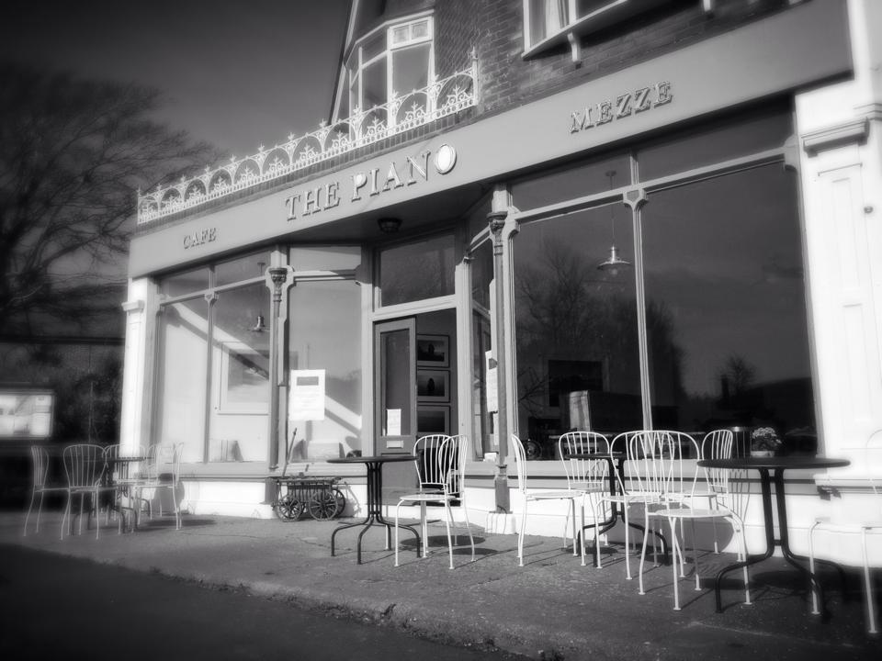

Friday 25th July 2-4pm: Brighstone Primary School

Monday 28th July 2-4pm: St. Saviours’ RC Primary School

The Piano Café, Gate Lane, Freshwater Bay
01983 472874 www.thepianocafe.co.uk

