Scope exists to make this country a place where disabled people have the same opportunities as everyone else. Until then, we’ll be here.

We provide support, information and advice to more than a quarter of a million disabled people and their families every year. We raise awareness of the issues that matter.

And with your support, we’ll keep driving change across society until this country is great for everyone.

To find out more about Face 2 Face in this   
area contact:

**01983 529 312 deborah.cobb@childrenssociety.org.uk  
www.scope.org.uk/face2face**



Call 0808 800 3333 to let us know

if you’d like this information in a format

that’s accessible for you.

Working in partnership with

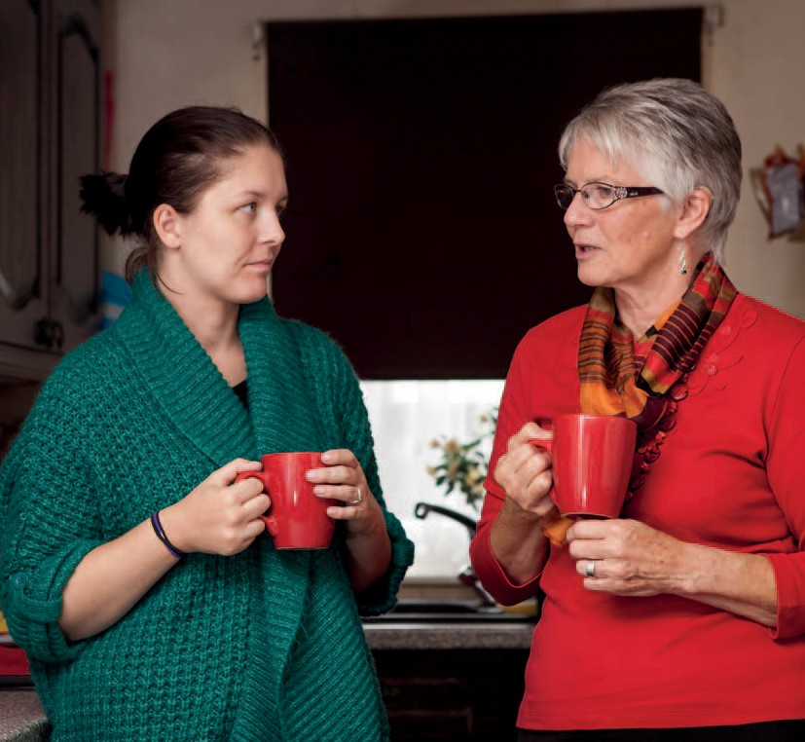

**Face 2 Face**Free and confidential service linking parents of disabled children with local parent befrienders.



**“My befriender helped me get through this worrying and confusing time and now I feel I can look more positively towards my child and my family’s future.”** **Bel   
  
Our service**

You’ve learned your child has support needs. Other parents have been there too. Talking to someone who understands can be very reassuring and help you to look more positively to the future. That’s where Face 2 Face can help – we’re local and we’re by your side.

Face 2 Face is a network of trained, volunteer parent   
befrienders who support you to successfully navigate through   
the worrying and confusing experience of having a child   
diagnosed with support needs.

**Our befrienders**

Every Face 2 Face befriender is a parent of a disabled child too. They understand and from their own experience can offer you friendly and knowledgeable support. Every Face 2 Face scheme   
is run by an experienced coordinator and all of our volunteer befrienders receive training and ongoing support.

**Accessing our service**

You can self refer or be referred by any care or support professional. The coordinator will then introduce you to a befriender who will visit you at home (or in a location convenient for you) for sessions lasting one hour. These can be weekly or when it suits you best.