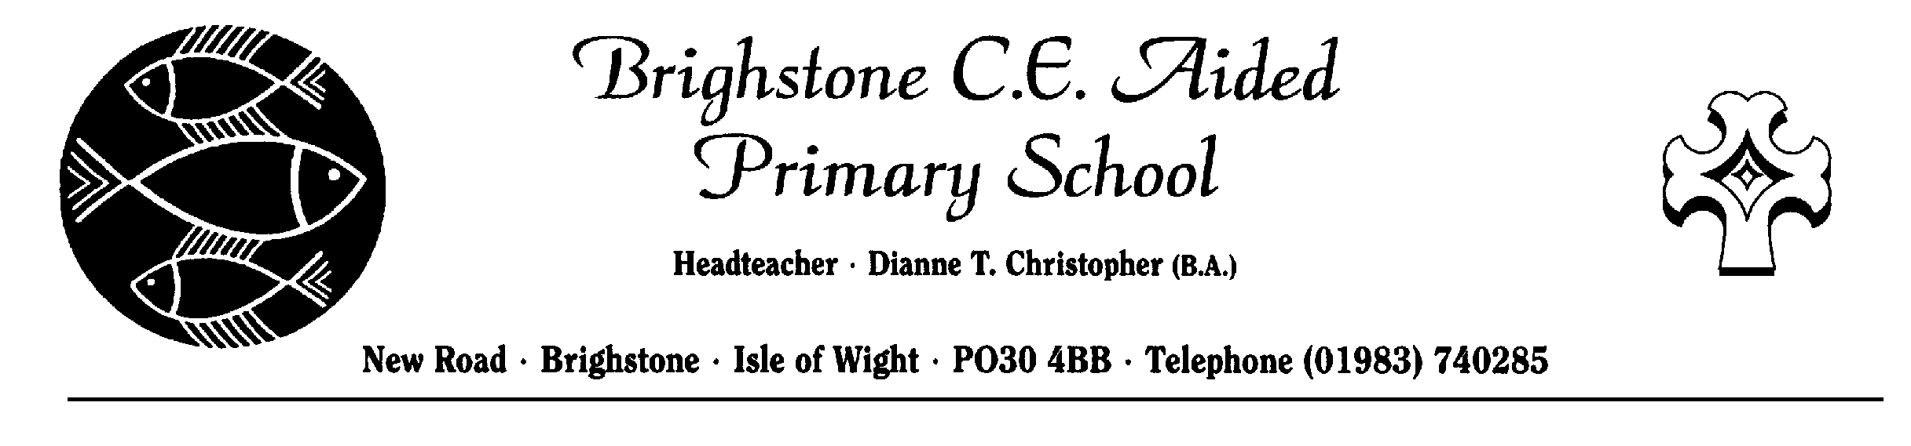 Administration of Medicine Form
Head Teacher – Mrs Teresa Fox
New Road – Brighstone – Isle of Wight – PO30 4BB – Telephone (01983) 740285

The school will not give your child medicine unless you complete and sign this form. The school has a policy that staff can administer medicine.
Date
Name of school | Brighstone C.E. (Aided) Primary
Name of child
Date of birth
Group/class/form
Medical condition or illness
Medicine
Name of and type of medicine
(ie tablets, medicine)
Expiry date
Dosage and method
Timing
Special precautions/other instructions
Are there any side effects that the school/setting needs to know about?
Self-administration – y/n
Procedures to take in an emergency
NB: Medicines must be in the original container as dispensed by the pharmacy

Parent/Guardian Contact Details
Name
Daytime telephone no.
Relationship to child
Address
I understand that I must deliver and collect the medicine personally to and from | The School Office
The above information is, to the best of my knowledge, accurate at the time of writing and I give consent to school/setting staff administering medicine in accordance with the school/setting policy. I will inform the school/setting immediately, in writing, if there is any change in dosage or frequency of the medication or if the medicine is stopped.

Signature(s) Date

Date
Time given
Dose given
Name of member of staff
Staff initials
Date
Time given
Dose given
Name of member of staff
Staff initials
Date
Time given
Dose given
Name of member of staff
Staff initials
Date
Time given
Dose given
Name of member of staff
Staff initials

Date
Time given
Dose given
Name of member of staff
Staff initials
DO NOT THROW THIS FORM AWAY, PLEASE FILE IN MEDICATION FOLDER.

