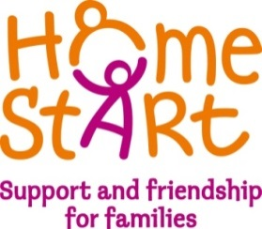

HELLO
IS IT YOU WE’RE LOOKING FOR ?

We need volunteers in your area to support families.
If you think you have the right skills, and can offer a couple of hours a week we would love to hear from you.

For full details of the role and the training please contact us on 533357, admin@homestartiow.org or find us on Facebook

