“IRON ON”
SCHOOL
CLOTHES LABELS

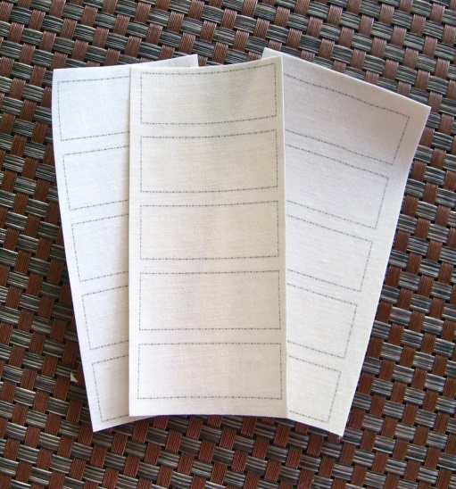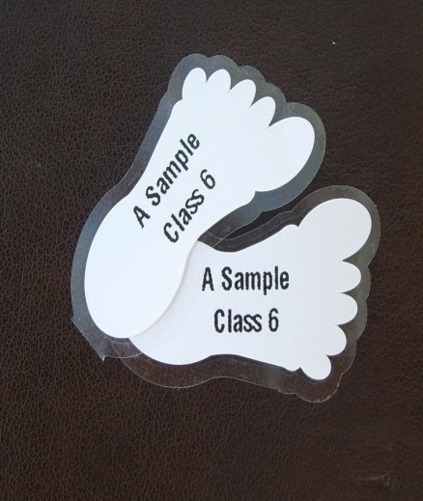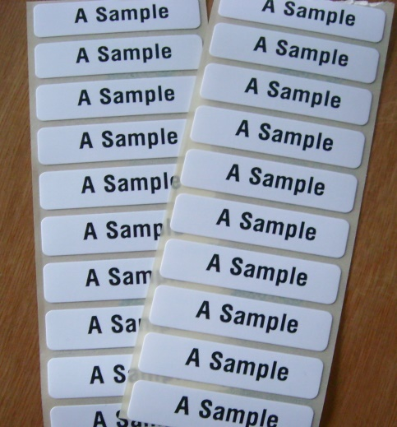

15 Plain Name Labels £ 0.99 15 Printed Name Labels £ 1.99
25 Plain Name Labels £ 1.60 25 Printed Name Labels £ 2.99
50 Plain Name Labels £ 3.00 50 Printed Name Labels £ 4.99

Peel & Stick Shoe Labels - 5 pairs for 99p

Order From - www.labelcreating.co.uk

Email - labelcreating@gmail.com

Tel - Marion - 07754 515586

