We are now offering Ofqual regulated
Level 2
and
Level 3
Safeguarding Children, Young People and Vulnerable Adults
From £32pp
We run Ofqual regulated first aid and food safety courses and awareness courses , we offer support with health and safety, risk assessments, HACCP and COSHH.

We are flexible in that we can offer Saturdays and evenings and we can come to you.

We can adapt our courses to better fit your specific needs
Please contact us to find out more
Newsletter
Issue 4 July 2018
Jigsaw Training and Development Services
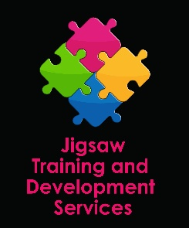
Did You Know?
We offer a consultancy service in food safety, and health and safety
We offer pre EHO visits to your premises
We offer support following EHO visits

Happy Birthday to us!!
We are celebrating our first birthday
To help us celebrate, please email to tell us what kind of training you are most interested in. There will be prizes!
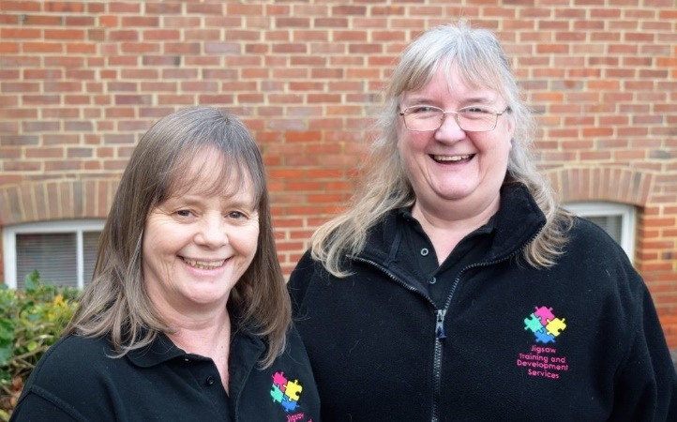

During our first year, we have joined the IOW Chamber of Commerce and enjoyed networking breakfasts and events. We have worked with schools, nurseries and childminders delivering first aid and safeguarding training. We have worked with community groups to raise awareness of food safety and first aid. We have delivered food safety training to those setting up in business and those with a lot of experience. We have assisted rapidly growing businesses with health and safety policies and procedures. We have had an incredible time and have met so many amazing people. Thank you all

LearnFest IOW
Believing learning to be lifelong, we are running a festival of learning at YMCA Winchester House on Saturday September 29th 2018 from 10am – 4pm. The intention is to showcase the wide variety of learning opportunities available on the island for all ages.
If you teach, train or coach and would like to find out more, please email us.

Jigsawtads@gmail.com 07708716725
Jigsaw Training and Development Services, Unit B3, Spithead Business Centre, Newport Road, Sandown, Isle of Wight PO36 9PH jigsawtads@gmail.com 07708 716725
Unit B3, Spithead Business Centre, Newport Road, Sandown PO36 9PH

