English |  |  | Maths
Read Write Inc  All Year 1 children are continuing to take part in the RWI programme and will be reading and writing about a range of books across the half term. See the weekly ‘home’ books for the green and red words to practise. |  |  | Number, Multiplication and Division  Count in multiples of 2’s, 5’s and 10’s  Solve one step problems involving multiplication and division, by calculating the answer using concrete objects, pictorial representations and arrays with the support of the teacher.  Number: Fractions  Recognise, find and name a half as one of two equal parts of an object, shape or quantity  Recognise, find and name a quarter as one of four equal parts of an object, shape or quantity  Compare, describe and solve practical problems for: lengths and heights ( for example, long/short, longer/ shorter, tall/short, double/half)  Compare, describe and solve practical problems for; mass/weight (for example, heavy/light, heavier than, lighter than); capacity and volume 9for example, full/empty, more than, less than, half, half full, quarter)  Geometry position and direction Describe position, direction and movement, including whole, half, quarter and three quarter turns.
Science |  | Year 1 Willow Class Topic Web  Summer Term 1 2018 |  | Art
Our Science will be focusing on Dinosaurs.  We will be observing and recognizing some simple characteristics of dinosaurs, identifying their similarities and differences, grouping dinosaurs according to given criteria, finding out what they ate including which ones were carnivores and herbivores.  We will also studying fossils. |  |  |  | All our Art activities will be based around our Dinosaur topic including designing and making our own dinosaurs thinking about specific characteristics and making dinosaur eggs by painting pebbles etc
Dinosaurs!
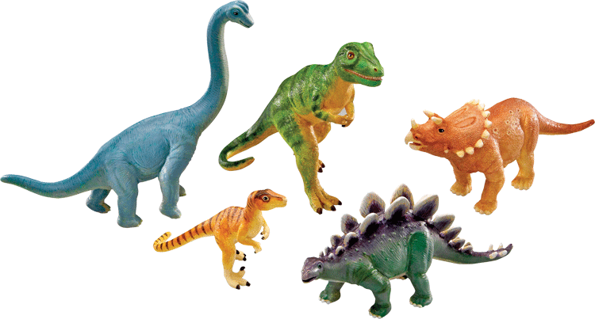

RE | PSHE | Topic Journal Writing |  | PE
Special books  We will be finding out about special books in Christianity and Judaism. | Going for Goals  We will be finding out about our short and long term goals, and how we can achieve them. | We will be writing journals in character, as Andy from ‘Andy’s Dinisaur Adventures,’ including facts they have learned about dinosaurs. Within the unit, they will also use other forms including non-fiction, making information posters about dinosaurs. |  | Games  We will continue to work with the sports coach.

