  - Good Friday

Coffee Morning
Pop along to our Easter Coffee Morning, enjoy a hot cross bun, tea or coffee & catch up with friends. Craft area for the children, Easter raffle plus a pre-loved clothing area with bargains galore

Where: Shorwell Village Hall,

Russell Road, Shorwell

When: Friday 30th March

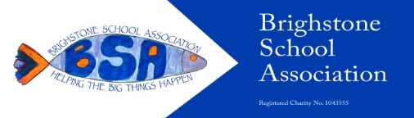
Time: 10am – Midday
Raising funds for Brighstone School

