Literacy |  |  |  | Numeracy
Our focus in Literacy this term is The Man on the Moon  This picture book will be our stimulus for writing diary entries. The story looks at a day in the life of Bob, the man who is busy working on the moon. He is not entirely alone in his work though, and several ‘helpers’ make an appearance. Our diary entries will reflect the views of these ‘helpers.’  SPAG  Punctuation and grammar are taught throughout all English sessions. When writing diaries pupils will be working on their organizational skills and developing vocabulary for chronological reports.  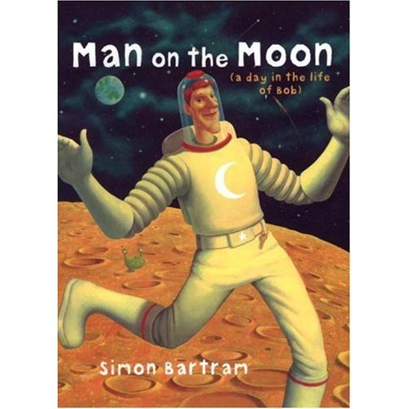  In Juniper Class we continue to have two aspects to Guided Reading. Pupils who need support with their phonic and reading skills will continue to have specific Read Write Inc sessions. Additionally some pupils will read War of the Worlds (abridged for children) during guided reading sessions. |  |  |  | 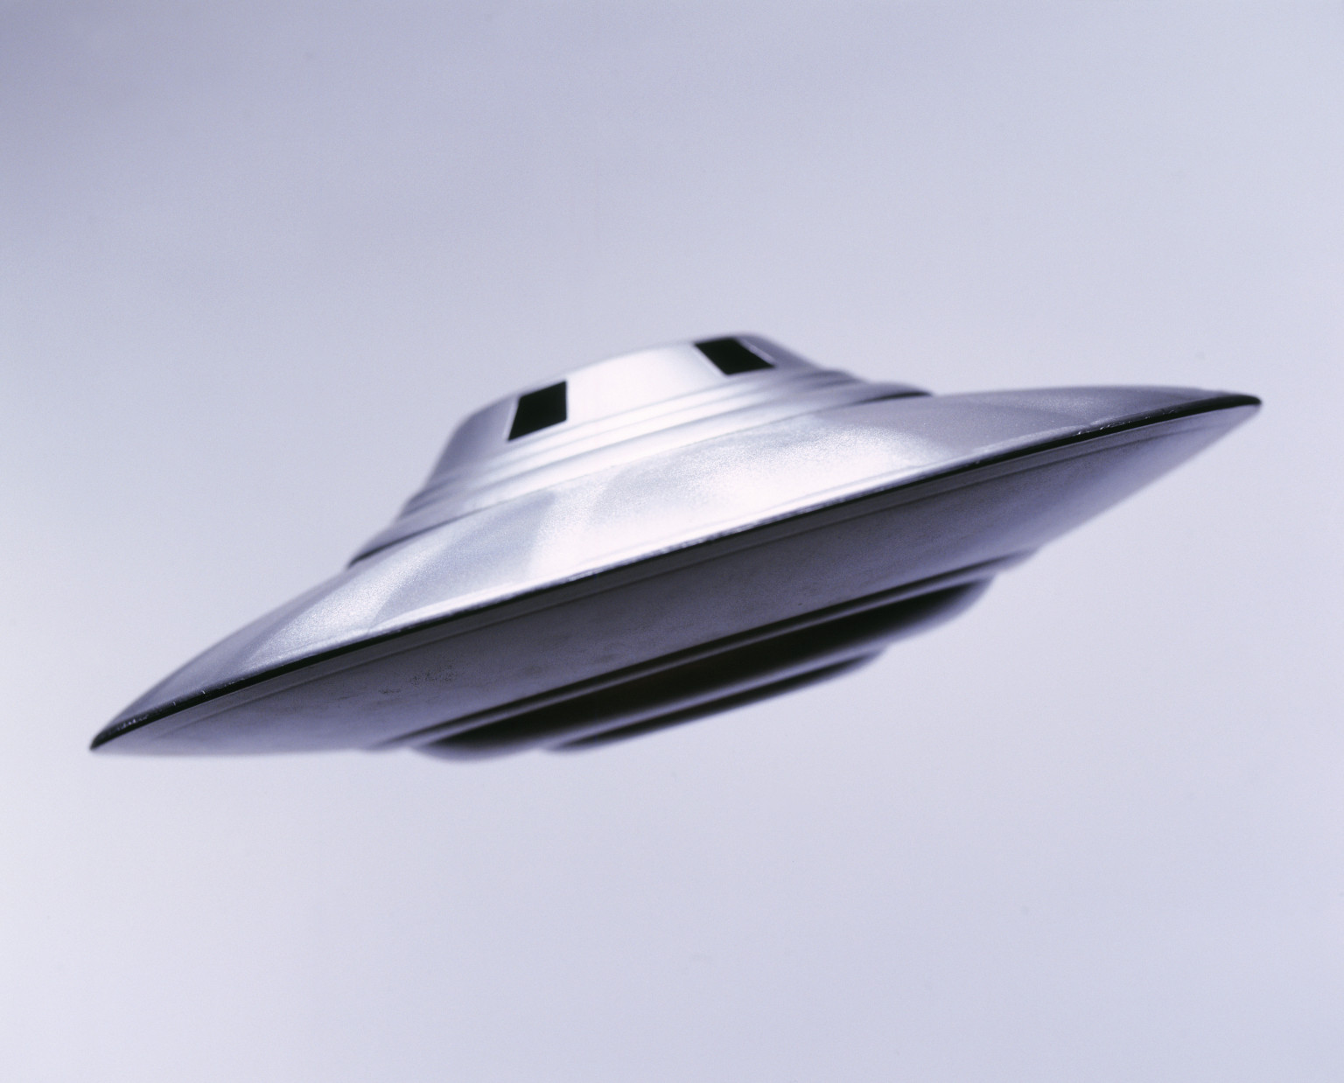  Numeracy this term:  Place Value – the pupils will return to developing their skills in using and applying place value. They will move on to working with numbers to 1000.  Addition: In Juniper pupils will continue to learn how to add using two and three digit numbers. The focus this term will be using expanded addition, where pupils using a column method but expand the numbers so that they can see each aspect of the number when adding.  Fractions: This term fraction work will focus on finding fractions of shapes and looking at simple equivalents. Throughout fraction work pupils will continue to use their knowledge of multiplication and division.  Shape, Space, Measure: Throughout the term pupils will explore Shape, Space and Measures through their scientific work and through problem solving using units of measure for length, weight and volume.
Science |  | Juniper Class Topic Web  Spring 1 2018 |  |  |  | History
This term the focus for science is magnets and forces. As part of our integrated topic work on space pupils will learn about repelling, attraction, magnetic poles and discuss how objects move when a force is applied. They will design scientific experiments using their enquiry skills. Observe, gather data and reporting on findings will see them use key scientific skills to develop their understanding of magnets and forces in addition to developing appropriate vocabulary. |  |  |  |  |  | 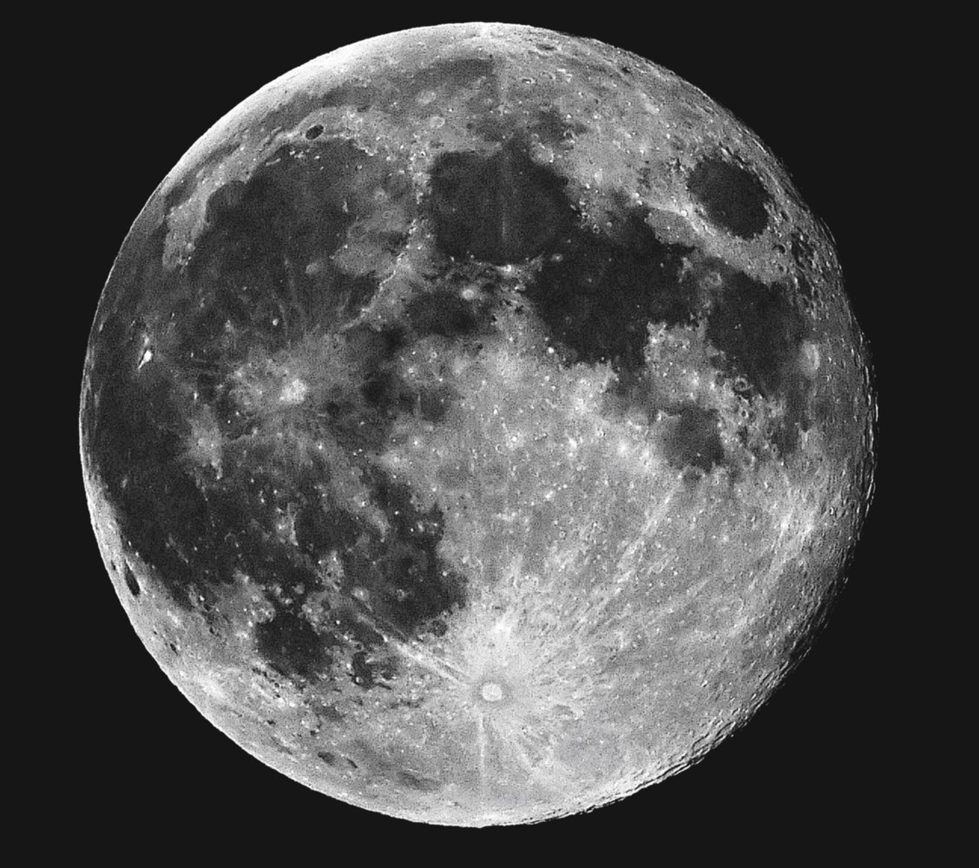  This term we are looking at the history of space travel and familiarizing ourselves with the chronology of the development starting as early as the Greeks and making our way through to the present day. Along the way we will explore a variety of aspects of astronomy including finding out about the international space stations and space exploration.
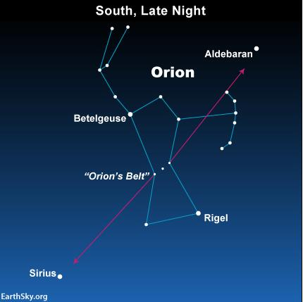
To Infinity and Beyond
RE | PSHE | French | Art |  | DT | PE | Music
Hinduism - In RE this half term, we will be exploring the theme of devotion through looking at Hinduism. We will enquire, contextualise, evaluate, communicate and apply through this theme. | Relationships  Pupils will learn how develop and maintain relationships with others. They will also know how to make positive comments about others. | In French the pupils will consolidate their understanding of numbers and dates. They will begin to learn about animals and begin to describe pets. | In art this term the pupils will learn two new techniques -diffusing and marbling. They will also explore pop art in order to make their own pop art aliens. |  | In DT we will be making Moon Buggies. The children will design, make and evaluate buggies to develop their design technology skills. | PE coaches will be working with children this term on a variety of ball skills and games. They will work on their teamwork skills in addition to learning new strategies. | Mr Stroud will continue to teach brass to Juniper pupils on Friday afternoons.

